Campi 280
User manual
PL-RIV000
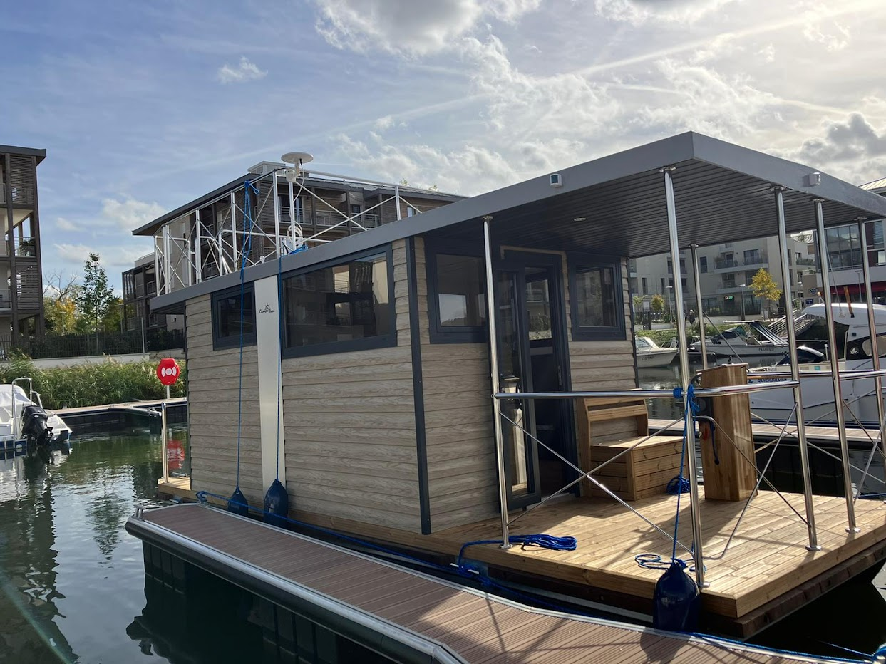

Table of Contents
- General.................................................................................................................................................3 1.1. Introduction…..................................................................................................................3 1.2. Conditions at sea.............................................................................................................3 1.3. Warning symbols…..........................................................................................................4
- Ship details………...................................................................................................................................5 2.1. Basic dimensions……….....................................................................................................5 2.2. Deck systems………...........................................................................................................5 2.3. Tank capacity…………........................................................................................................5 2.4. Project category…............................................................................................................6
2.5 .Identification Numer…………………………………………………………………………………………………6
2.6. General plan……...............................................................................................................7
- Ship installations, description, and location………...............................................................................7 3.1. Control console...............................................................................................................8 1 1. Engine control.....................................................................................................................9 2. Steering wheel....................................................................................................................9 3 3. Ship sound signal…..............................................................................................................9 4. Terrace lighting...................................................................................................................9 5 5. Navigational lighting...........................................................................................................9
- Drinking and dirty water level indicator............................................................................................10
- Camera system...................................................................................................................................11
- Description of electrical installation ……………...................................................................................11 6.1. Battery location and maintenance……..........................................................................12 6.2. Inverter / charger …..………............................................................................................13 6.3. Fuses…………...................................................................................................................14
- Drinking water system.......................................................................................................................15 7.1. Filling the drinking water tank ……….............................................................................17 7.2 Switching between the tank and the permanent water connection............................17 7.3 Sewage disposal system…………......................................................................................17 7.4 Switching between the tank offboard / storage tank…………………..…………………...........18 7.5 Emptying the storage tank ………………………………………….…………...................................18
- Gas installation...................................................................................................................................19 8.1. Cylinder type / connections ……………...........................................................................19 8.2. Gas cylinder replacement.............................................................................................20
- Heating…............................................................................................................................................21 9.1. Operating modes ..........................................................................................................22
9.2. Types of heating……………………………………………………………………………..…………………….…25
- Sailing with Campi280 ..…..................................................................................................................26
- Fuel system………................................................................................................................................26 11.1 Lubricating oil level………..............................................................................................27 11.2. Engine start……………….................................................................................................28
- Maneuvering .....................................................................................................................................29 12.1.Mooring........................................................................................................................30
- Overwintering ….................................................................................................................................30 13.1. Frost.............................................................................................................................30 13.2. Absence during frost or extended period………………………….......................................31 13.3. Winterization of engines………………............................................................................31
- Safety.................................................................................................................................................31 14.1. Man overboard prevention……………...........................................................................31
- Escape routes……...............................................................................................................................32
- Advice on resources to acquire……………………………..........................................................................32
- Error table……....................................................................................................................................33
1. General
1.1. Introduction
This manual is intended as a technical guide, providing explanations of the various systems on board the Campi280 vessel and assisting in the identification of potential faults.
It describes the onboard systems of the Campi280 and helps to diagnose possible malfunctions.
1.2. Sea Conditions
Shut-off valve | Tap/valve to open or close the pipe
Port side | Left side of the vessel as seen from the front
Starboard | Right side of the vessel as seen from the front
The side it blows into | to which the wind blows
The side from which the wind blows | from which the wind blows
bolt | screw provides thrust in water
RPM | Rotations per minute
sewage | Sewage from the toilet (and sink)
The significant wave height | The significant wave height is the average height of the highest 1/3 of the measured waves
Balustrades | Handrails / guardrails preventing falling overboard
trimming | Adjusting the outboard motor longitudinally.
Ship horn | Sound signal horn
power supply | Electrical connection to shore (230V 50Hz).
hatch | The opening in the tank allowing inspection
Pressure regulator | Pressure reducing valve in the bottle to 50 mbar
pump | Black hand pump for pumping gasoline into the engines
Man overboard | Man overboard
Engine choke | Choke valve for the engine to suck in more gasoline

1.3 Warning symbols
The following symbols are used in this manual to identify dangerous situations and indicate hazards
WARNING FIRE HAZARD

DANGER DANGER OF POLLUTION
 
LIFE THREAT


2. Ship details
2.1 Basic dimensions
Length: 7,50 [m]
Width: 2,80 [m]
Draft: 0,45 [m]
Height: 3,50 [m]
Displacement: 7,5 [m 3 ]

2.2 Układy pokładowe

Engine: Yamaha 9.9 hP
Solar panels: 2x6 V 400 W
Battery capacity: 2x 12v 200Ah
Inverter: 3 kW

2.3 Tank Capacities

Drinking water: 250 Liters
Sewage tank: 250 Liters
Gasoline: 2x 12 Liters

2.4 Project category

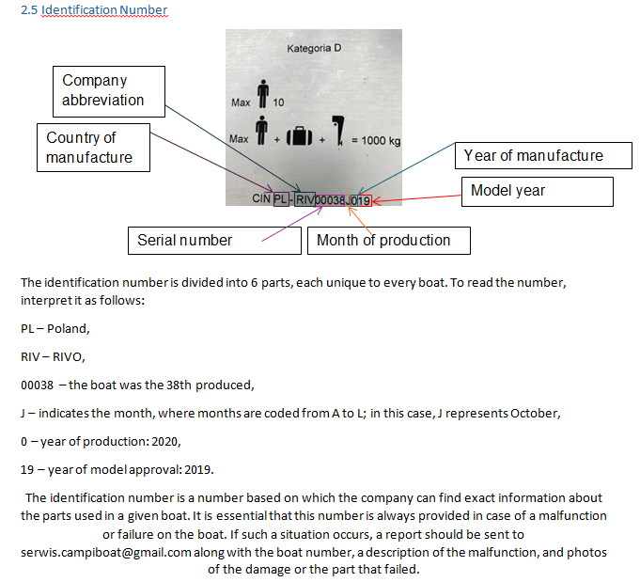
The design category defines the maximum (meteorological) conditions (wind and sea conditions) for which the vessel is intended. The Campi280 has been designed and built for use under Design Category D, with a recommended maximum capacity of 10 people. This category pertains to vessels designed for use in waves up to a maximum height of 0.3 meters and wind force of up to 4 on the Beaufort scale. Category D – “Inland Waters”: Designed for navigation on protected waters along the coast, small bays, small lakes, rivers, and canals, with a maximum wind force of 4 and maximum wave height not exceeding 0.3 meters, occurring occasionally. The minimum distance from passing vessels should not exceed 0.5 meters.

2.6 General plan
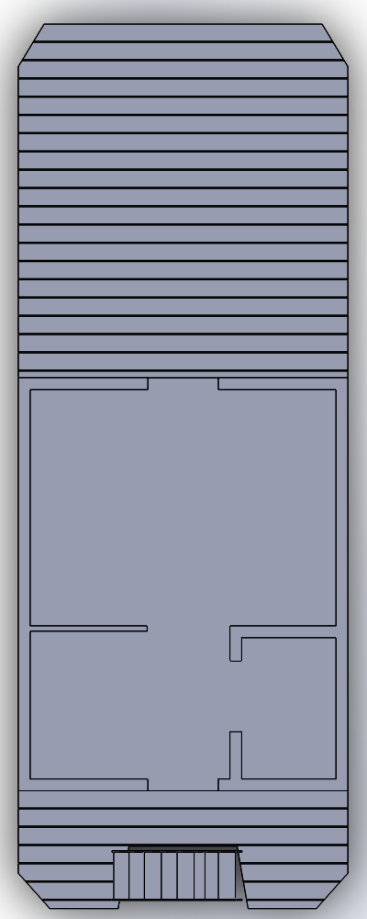

3. Ship installations, description, and location

The following sections describe the technical operations and the locations of the onboard equipment. A detailed guide for starting and sailing the Campi280 can be found in Chapter 4.

3.1 Control console

The control console contains all the necessary switches and instruments for operating the engines and the Campi280’s (navigation) devices. The picture below shows the function of each button.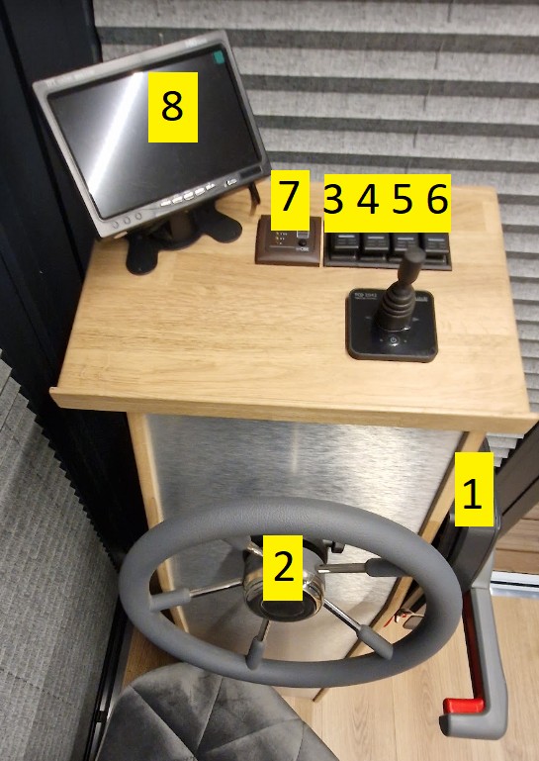
9

1) Engine control 2) Steering wheel 3) Ship horn 4) Terrace lighting 5) Navigation lights 6) Monitor switch 7) Freshwater and wastewater level indicators 8) Camera system 9) Bow thruster system

1 Engine Control
Port Side and Starboard: The engines are operated using the "throttle levers" located on the left and right sides of the control console. The left throttle lever (port side) controls the port engine, while the right throttle lever (starboard side) controls the starboard engine. A detailed manual on operating the throttle levers and engines can be found in Chapter 4.
2 Steering Wheel
The steering wheel is connected to both engines via a hydraulic system. Turning the wheel to the left causes both engines to rotate through the hydraulic actuator, allowing the Campi280 to turn to port or starboard when moving forward.
3 Ship Horn
Pressing button 3 on the control console triggers short sounds from the ship's horn.
4 Terrace Lighting
Switching toggle switch no. 4 turns the terrace lighting on or off.
5 Navigation Lights
Switching toggle switch no. 5 activates the navigation lights. The navigation lights consist of the following lamps:
- Red light on the port side (left)
- Green light on the starboard side (right)
- Stern light (white lamp at the stern)
- Bow light (white lamp facing forward)
The navigation lights should be switched on when traveling at night or in poor visibility conditions.
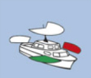

4 Drinking and dirty water level indicator

The following instrument measures the capacity of the drinking water and sewage tanks by pressing the black button. The drinking water tank is divided into 4 different lights.
• 4 points = 400 liters
• 3 points = 300 liters
• 2 points = 200 liters
• 1 point = 100 liters
When the light in figure 5 illuminates, it means that the sewage tank is full.

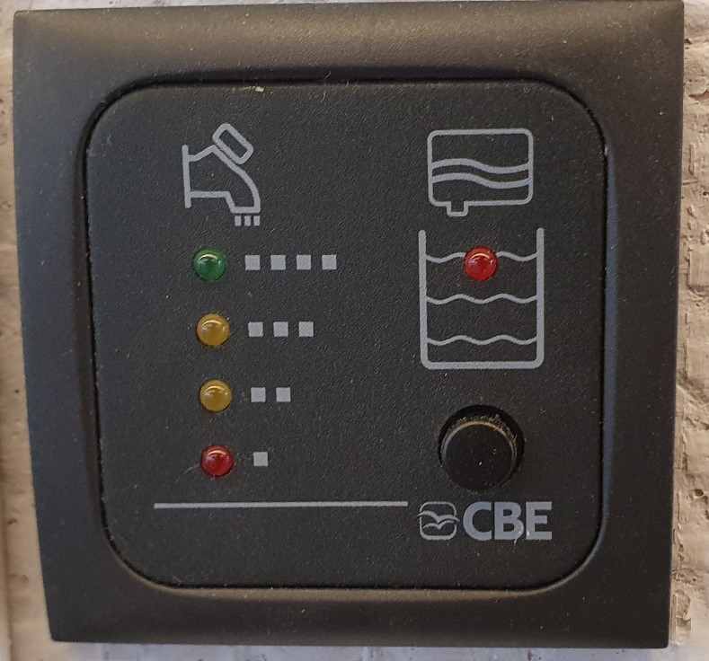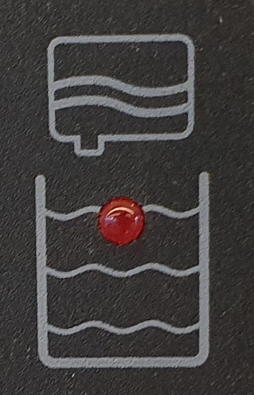

5. Camera system
Figure 7 shows the camera system display. This system can be turned on and off using the On/Off button on the screen as well as a switch on the control console to prevent the monitor from overheating. The Campi 280 is equipped with a single camera located at the rear of the boat. 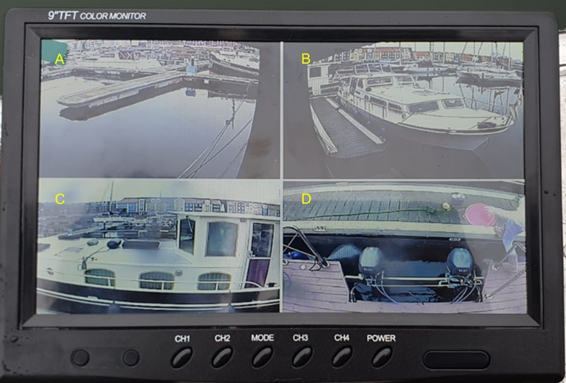 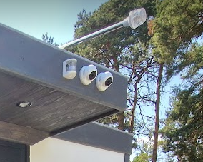

6. Description of electrical installation
The electrical system of the Campi280 is designed so that the vessel can be powered by batteries independently of shore power. This is achieved through a combination of batteries, an inverter, shore power, and solar panels. Below is a brief description of these four components:
Batteries (carbon batteries)
The batteries are charged using solar panels and/or shore power. The Campi280 is equipped with 2 x 12V 200Ah batteries connected in series. Together, these batteries have a total capacity of approximately 10.5 kWh at 24 volts. They supply direct current (DC) to the inverter and, via DC/DC converters (48/24 & 48/12), power small DC devices such as the ship's horn and navigation lights.
Inverter
The inverter converts 48-volt direct current into 230-volt alternating current (AC), typically used by standard power sockets. This AC power is distributed throughout the vessel and is available via the onboard sockets.
Solar Panels
The solar panels generate energy to charge the batteries when the Campi280 is not connected to shore power. On a sunny summer day, the solar panels produce enough energy to fully power the Campi280 and fully recharge the batteries. As night falls, the solar panels' output decreases, and the batteries gradually discharge.
Shore Power
When the Campi280 is connected to shore power, it supplements the inverter and solar panels to charge the batteries and supply power to the vessel.
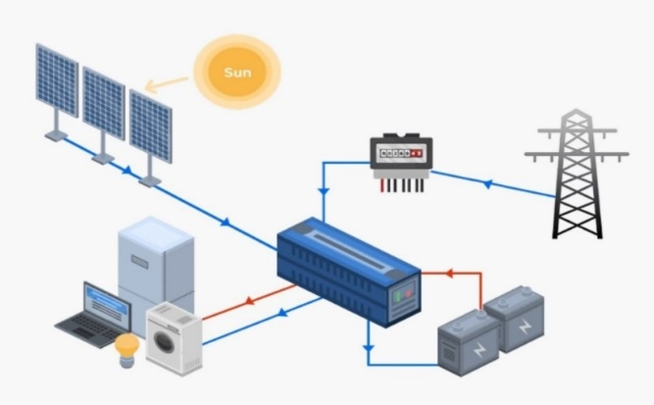
6.1 Battery location and maintenance
The batteries on the Campi280 are located under the floor in the salon.During the autumn and winter months, the batteries should be connected to a charger to prevent complete discharge. If the batteries become fully discharged, issues with the inverter may occur. In such a case, the batteries should be removed and recharged to avoid further problems.

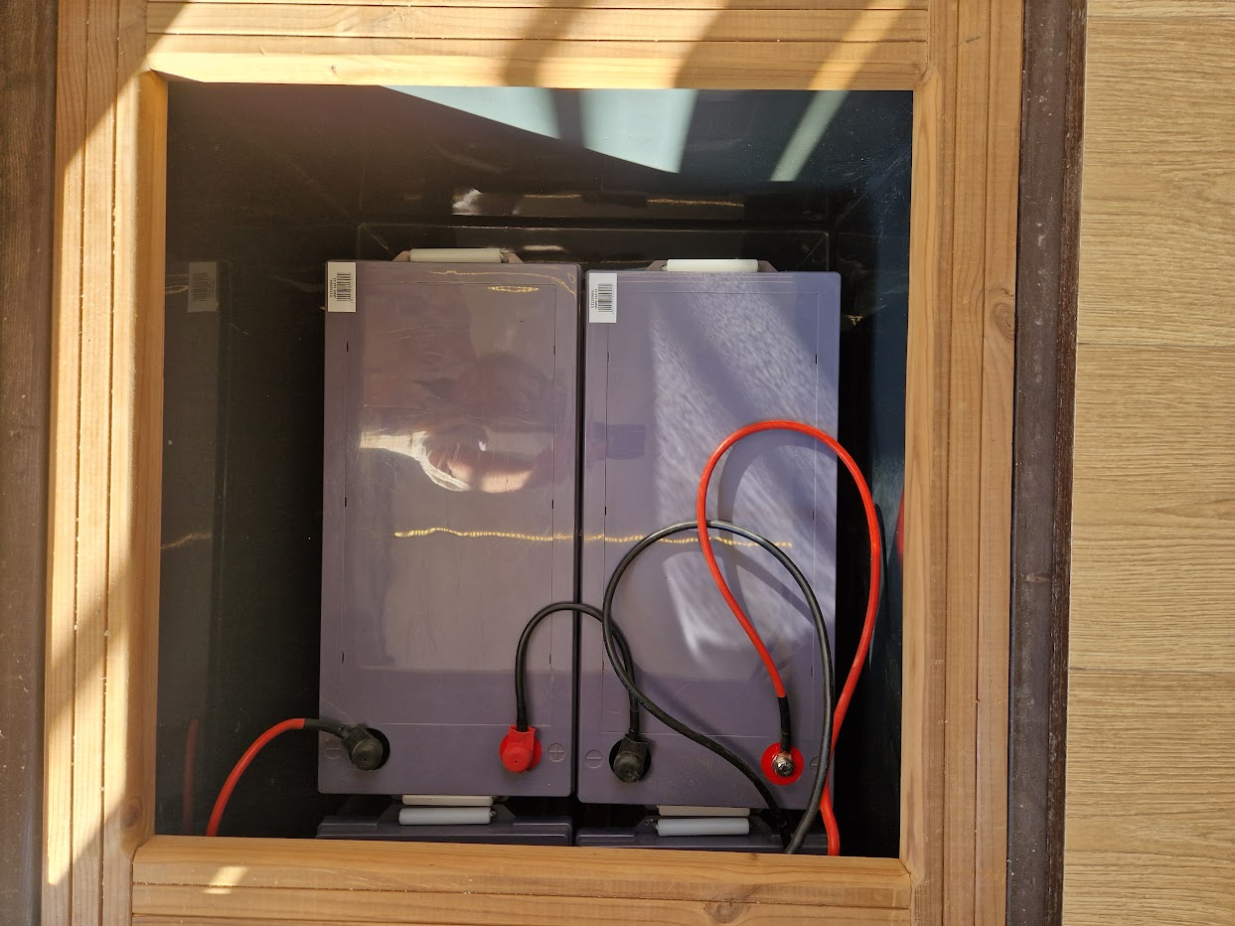

6.2 Inverter / charger
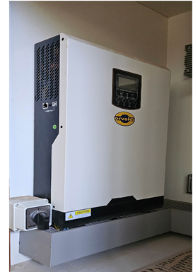
The inverter/charger is a device that converts the direct current (DC) from the batteries and solar panels into 230-volt alternating current (AC). This device also charges the batteries whenever shore power is available.The inverter is an independent unit that automatically switches between shore power, batteries, and solar panels. It is located behind the upper doors at the stern.

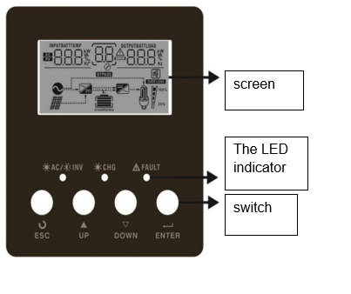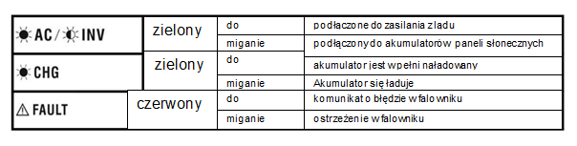
Inverter warning
Inverter error message
The batteries are charging.
The battery is fully charged.
Connected to the batteries/solar panels
Connected to shore power
blinking
Light is on
blinking
Light is on
blinking
Light is on
red
green
green

6.3 Fuses

The fuses are located behind the upper doors at the stern. The fuses distribute power throughout the Campi280 and protect the electrical system from short circuits, overloads, and ground faults. Below is a brief explanation of overloads and ground faults:

Overload/Short Circuit:

An overload occurs when the current flowing through the system exceeds the level for which the system was originally designed. This overload causes additional heat generation and can lead to machinery shutting down.

Residual Current Device (RCD):
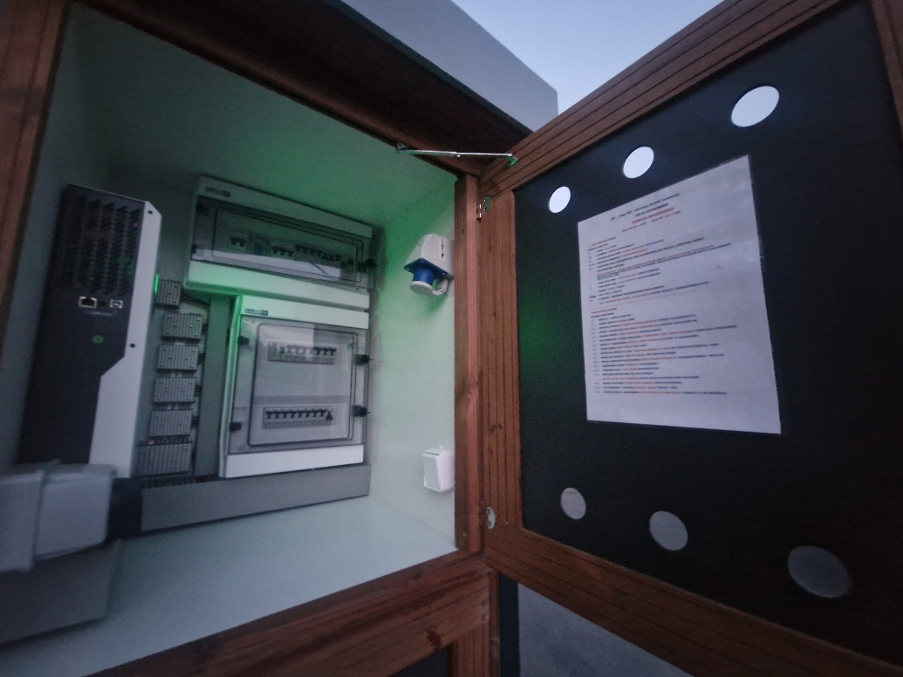
The RCD is an automatic switch that disconnects the electrical system when a leakage current above a certain threshold is detected. This device prevents leakage currents that could cause electric shock.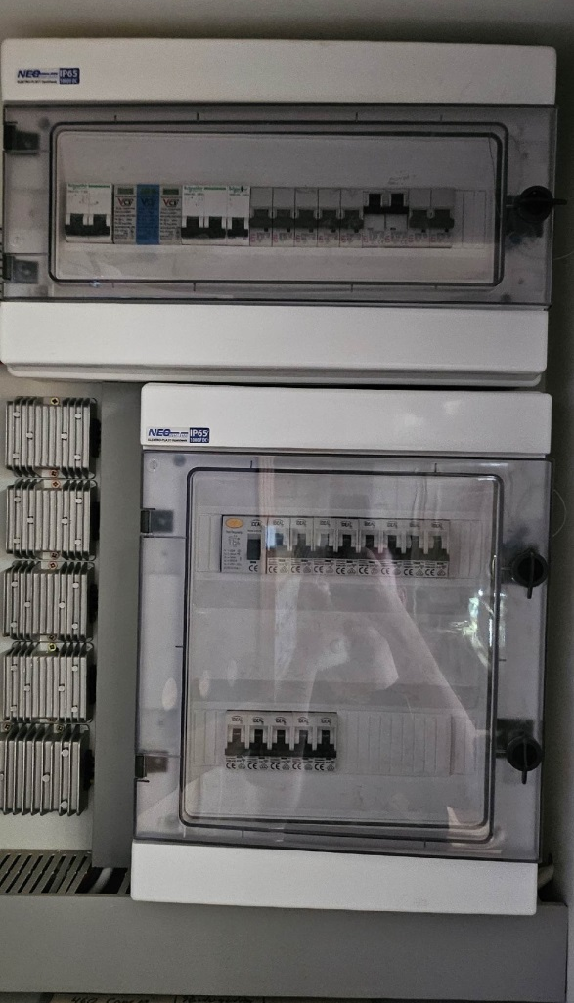
Each boat has an individual fuse box depending on its equipment. A detailed description of the fuses is included in the boat’s documentation and also on the fuse box door. The inside of the electrical panel is sealed with tamper-proof seals.
Warning! Breaking the seal on the electrical panel will void the warranty.

DANGER TO LIFE! Any modifications to electrical installations (and devices) may only be carried out by authorized personnel.

7. Drinking water system
The Campi280 is equipped with a 250-liter freshwater tank. The tank is located under the floor between the two floats and is accessible through hatch [B]. The freshwater system consists of the following components:
A. Freshwater pump
B. Inspection hatch
C. Frost protection [optional]
D. Pump outlet pipe [optional]
E. Fixed water drain connection [optional]
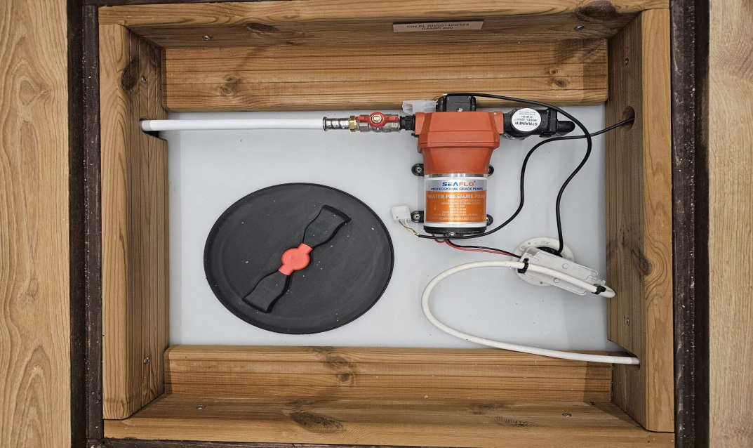
The freshwater pump activates when the pressure drops (when a tap is opened) and stops running once the pressure reaches the appropriate level. It is possible for the pump to continue running for a few minutes after the tap has been closed.
WARNING! If the water tank is completely empty, the pump will continue to run in an attempt to build up pressure. However, this will not work because the tank no longer contains water. In this case, the pump must be switched off manually by turning off switch X in the distribution box (see the overview next to the distribution box). Once the tank has been refilled with water, the pump can be switched on again.

Freshwater Pump (optional)
If the Campi280 is equipped with the optional Marco pump, the pump will automatically switch off when there is no more water to pump. After refilling the tank with water, the pump must be manually reset. This can be done by unplugging and reconnecting the plug in the distribution box (see the overview). To help vent the pump, you can also loosen the Allen screw on the pump until water begins to flow out.
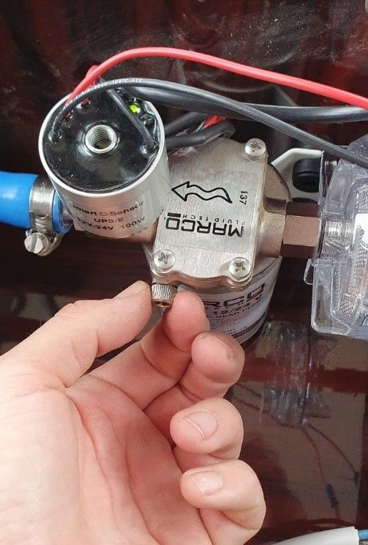

7.1 Filling the drinking water tank
The freshwater tank is filled through the freshwater filling inlet at the port. The filler cap is unscrewed using a special key provided in the document folder.
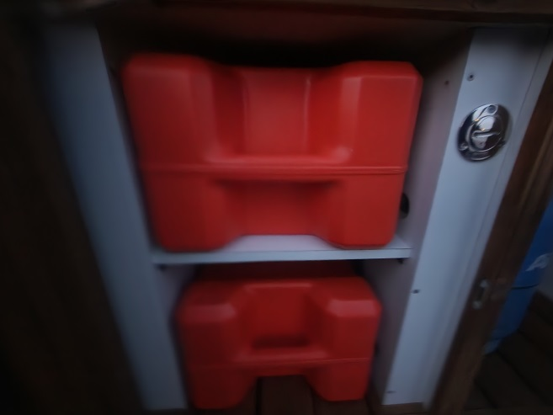
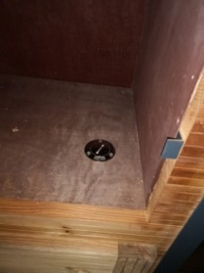
! WARNING! Always flush the water hose for a few minutes before inserting it into the filling inlet.

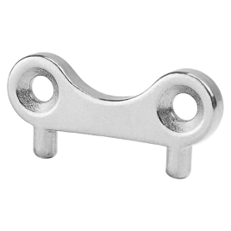

7.2 Switching between the tank and the permanent water connection

Optionally, Campi280 can be equipped with a permanent shore water connection. In this case, the pump must be turned off using switch X [see overview next to the group field], and valve D (in figure 14) must be perpendicular to the pipe, while valve E must be in the longitudinal direction of the pipe.

7.3 Sewage disposal system

Campi280 has a sewage tank with a capacity of 250 liters. The tank is located under the floor between two floats and is accessible through a hatch at the stern. Waste (from the shower, sink, and toilet) is collected in the sewage tank or can be directly discharged overboard.

7.4 Switching between the tank offboard / storage tank
With the Y-valves, you can switch between the holding tank and direct discharge overboard.
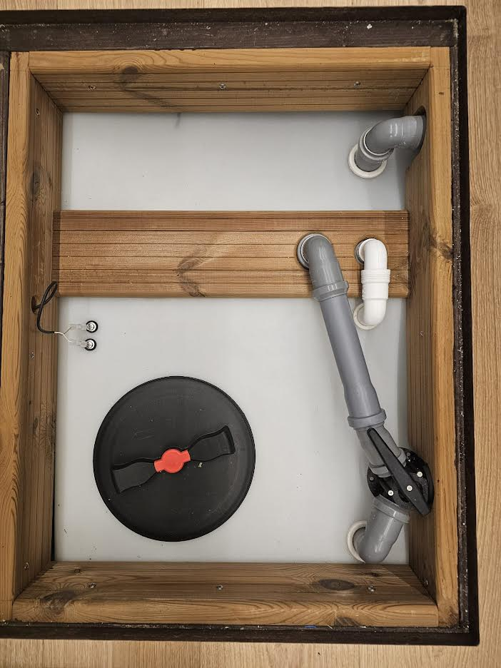

WARNING! Discharging wastewater into surface water is prohibited.

7.5 Emptying the storage tank
The waste holding tank can be emptied in one way:
1. At a designated pump-out station in the marina, the waste can be extracted via a suction hose connected to the screw-cap valve on deck.
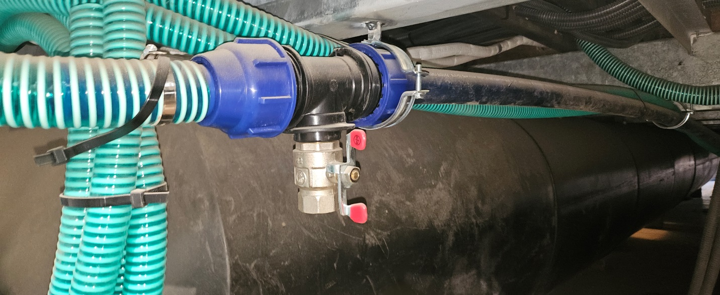

8. Gas installation
The gas cylinder is connected at the stern in the technical cabinet. The gas system consists of the following parts:
A. Gas cylinder (purchased by the customer)
B. Spare gas cylinder (purchased by the customer)
C. Gas cylinder valve
D. Gas pressure regulator
E. Gas shut-off valve
The gas cylinder is filled with 10.5 kg of propane and is opened by turning the valve on top of the cylinder. The gas flows through the pressure regulator, then through the gas shut-off valve, and through the pipes to the Campi280. The entire gas installation, including the materials used, complies with the ISO 10239 standard.

8.1 Cylinder type / connections
The type of gas used at the campsite should always be propane. This gas evaporates even at lower temperatures, ensuring that the central heating can operate during winter as well. The gas pressure regulator is most likely equipped with a DIN connection and, in such cases, should only be connected to a DIN gas cylinder! There are two options for connecting the gas cylinder:
- Jacket connection,
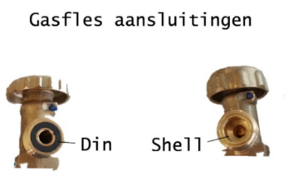
- DIN connection

The DIN connector has a raised iron edge but does not have a rubber gasket around the pin. The raised edge fits perfectly into the rubber gasket found on DIN valves.
The shell-type or external threaded connection has a sealing ring around the pin to seal the standard external threaded connection.
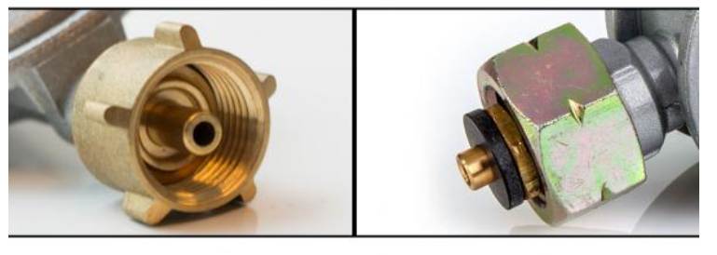
8.2 Gas cylinder replacement

As soon as the gas cylinder is empty, it must be replaced with a full one. Below is a step-by-step plan for safely replacing the cylinder and checking for leaks:
Disconnect:
- Close the gas shut-off valve (E).
- Close the valve (C) on the gas cylinder.
- Unscrew the gas pressure regulator from the gas cylinder (this is a left-hand thread, so to loosen it, turn it to the right).
Connecting:
- Check that the gas pressure regulator and the cylinder are of the same type (DIN or Shell).
- Inspect the gas pressure regulator for any damage.
- Attach the gas pressure regulator to the cylinder, tighten it by hand, and gently tap it with the gas cylinder wrench (or an adjustable wrench).
- Manually open the valve (C) on the gas cylinder.
- Apply soapy water or spray a gas leak detection spray on the connection.
- Are bubbles forming? If so, immediately close valve (C) and check the connection.
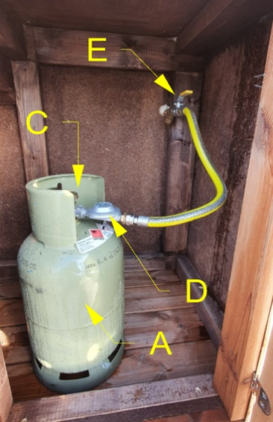
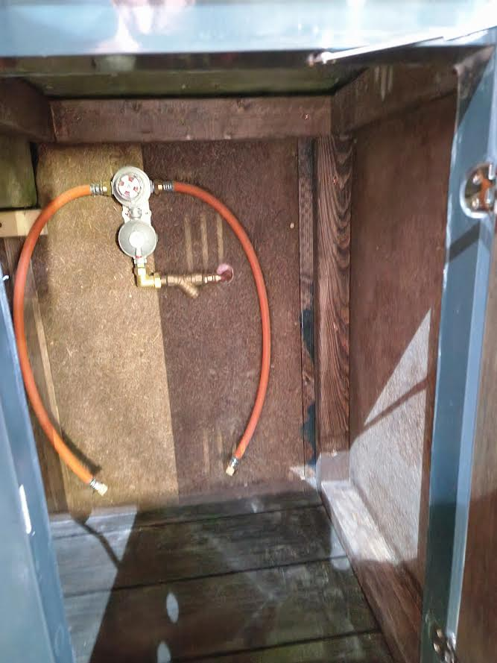
- If no bubbles appear, you can open the gas shut-off valve (E).
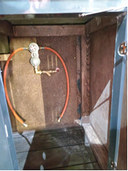

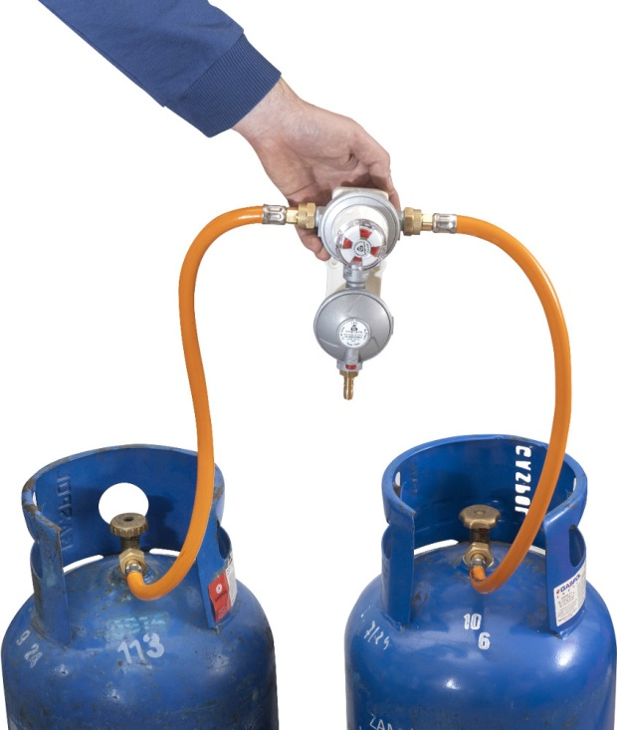

If the system is equipped with two gas cylinders, an automatic valve is installed. When one cylinder is empty, you should switch to the other cylinder by turning the white and red knob.

If both cylinders are empty, the cylinder replacement procedure is the same as for a single gas cylinder.
 
Fire hazard, life-threatening danger! A leaking gas system can lead to life-threatening situations. The gas installation must be inspected by certified gas installers at least every 3 years.

9. Heating
The central heating system is located in the cabinet next to the shower cabin. This boiler provides both heating and hot water. The boiler burns propane gas from the Campi280 gas cylinder. The temperature in each room can be regulated using thermostatic valves on the radiators. The gas valve must be open to use the central heating (even if the central heating is frost-protected)! After replacing the gas cylinder or when it is empty, connect the new cylinder as described earlier and leave the boiler running for about 2 minutes to purge air from the system.
Warning: After the heating season ends, do not close all thermostatic valves completely. Doing so will cause the inlet temperature to be higher than the outlet temperature, resulting in an error message. It is preferable to adjust the temperature using the control panel of the Junkers heating system.
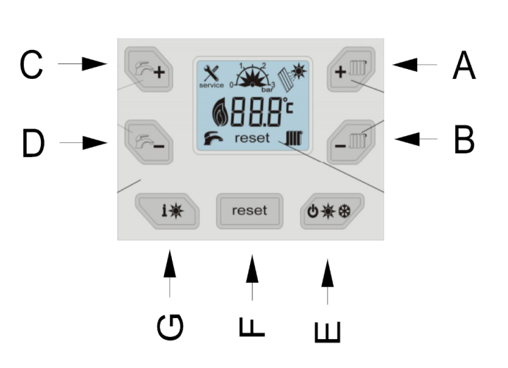
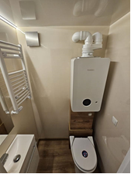

A. Heating temperature increase B. Heating temperature decrease C. Hot water temperature increase

D. Hot water temperature decrease E. Operating mode (summer, winter, frost protection)

F. Reset buton G. Information mode

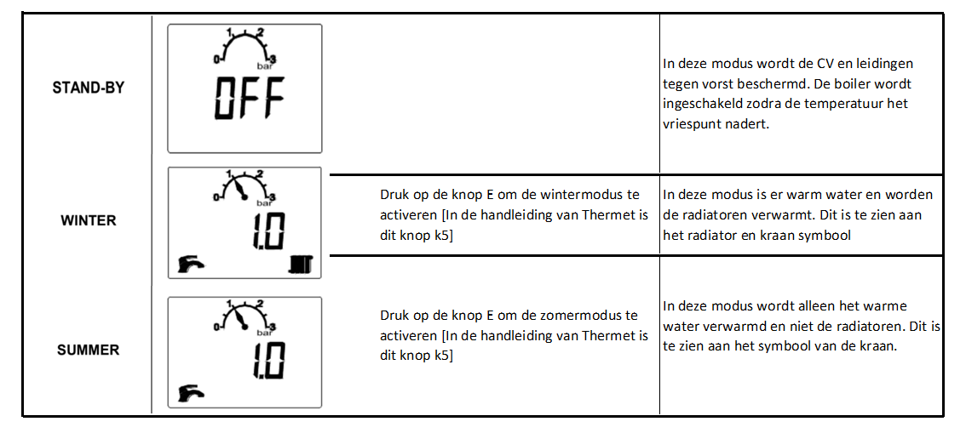
9.1 Operating modes
In this mode, the central heating (CV) and pipes are protected against freezing. The boiler will turn on as soon as the temperature approaches the freezing point.
Press button E to activate winter mode (in the Junkers manual, this is the kS button).
In this mode, hot water is available and the radiators are heated. This is indicated by the radiator and tap symbols.

In this mode, only the hot water is heated, not the radiators. You can recognize this by the tap symbol.
Press button E to activate summer mode (in the Junkers manual, this is the k5 button).

Error codes that may occur during operation:
200 – Boiler is in heating mode.
201 – Boiler is in domestic hot water preparation mode.
202 – Device is in start-up optimization program: time interval for burner reactivation has not yet been reached.
203 – Device is in standby mode, no heat demand.
204 – Current supply temperature is higher than the set supply temperature.
207 – Working pressure too low.
208 – Boiler is in chimney sweep mode.
212 – Too rapid temperature rise on safety sensor or boiler supply.
214 – Fan is switched off during safety time.
215 – Fan is running too fast.
216 – Fan is running too slow.
217 – Fan is not running.
222 – Supply temperature sensor damaged (short circuit).
223 – Supply temperature sensor damaged (open circuit).
224 – Flue gas temperature limiter or block temperature limiter triggered.
227 – Flame not detected.
228 – Flame signal detected despite burner off.
229 – Flame extinguished during burner operation.
231 – Power supply interrupted.
232 – Heating device blocked by external switching contact.
232 – Temperature limiter TB1 activated.
233 – Coding plug or device electronics fault.
234 – Electrical fault in gas valve.
235 – Conflict between device electronics version and coding plug.
237 – System fault.
238 – Device electronics damaged. Connection cable of gas valve, gas valve or control device damaged.
239 – Internal fault.
242 – Device electronics installation fault.
244 – Electronic system fault / basic controller fault.
246 – Internal burner controller error.
247 – Internal burner controller error.
257 – Internal burner controller error.
245 – Device electronics installation fault.
249 – Device electronics installation fault.
250 – Device electronics installation fault.
251 – Device electronics installation fault.
252 – Device electronics installation fault.
253 – Device electronics installation fault.
254 – Device electronics installation fault.
256 – Electronic system fault / basic controller fault.
258 – Internal controller error.
259 – Device electronics installation fault.
261 – Timeout during first safety time.
262 – Device electronics installation fault.
263 – Device electronics installation fault.
264 – Air transport stopped during operation phase.
265 – Heat demand lower than supplied energy.
268 – Component test mode.
269 – Flame monitoring.
270 – Heating device startup in progress.
273 – Interruption: safety check after 24 hours of continuous operation.
275 – Test coding plug detected.
276 – Supply temperature sensor temperature > 95 °C.
280 – Timeout during retry.
281 – Pump not running or dry run detected.
282 – No feedback signal from heating circulation pump speed.
283 – Burner start.
284 – First safety time: Gas valve opening.
290 – Internal fault.
305 – Boiler temporarily unable to start according to DHW priority.
306 – After gas supply cut-off: flame detected.
323 – Controller communication failure.
328 – Short power supply interruption.
330 – External supply temperature sensor defective (hydraulic coupling).
331 – External supply temperature sensor defective (hydraulic coupling).
341 – Too rapid temperature rise in heating device.
342 – Too rapid temperature rise during domestic hot water preparation.
350 – Supply temperature sensor short circuit.
351 – Supply temperature sensor open circuit.
356 – Supply voltage too low for this heating device.
357 – Venting program active.
358 – Anti-blocking protection active.
360 – Incorrect coding plug.
361 – Incorrect coding plug.
362 – Service coding plug detected.
363 – Device electronics system fault: ionization signal test failed.
364 – Solenoid valve EV2 leaking.
365 – Solenoid valve EV1 leaking.
604 – Burner control system fault.
810 – Domestic hot water temperature not increased for 2 hours.
815 – Hydraulic coupling temperature sensor damaged.
1010 – No communication with BUS system.
1011 – Domestic hot water temperature sensor damaged.
1012 – Storage tank temperature sensor damaged.
1013 – Maximum ignition time reached.
1013 – Interval time between inspections reached. Inspection required.
1014 – Ionization current too low.
1017 – Water pressure too low.
1018 – Service interval expired.
1021 – Domestic hot water temperature sensor damaged.
1022 – Domestic hot water temperature sensor damaged.
1023 – Maximum operation time including standby reached.
1025 – Return temperature sensor damaged.
1028 – Mixing valve temperature sensor damaged.
1065 – Pressure sensor damaged or not connected.
1068 – External temperature sensor or lambda probe damaged.
1073 – Supply temperature sensor short circuit.
1074 – No supply temperature sensor signal.
1075 – Block temperature limiter short circuit.
1076 – No block temperature limiter signal.
2051 – Internal error.
2052 – Maximum ignition transformer activation time exceeded.
2085 – Internal burner control fault.
2908 – Internal burner control fault.
2909 – Device electronics / basic controller system fault.
2910 – Flue system fault.
2911 – Calibration failed.
2912 – No flame signal during calibration.
2913 – Flame signal too low during calibration.
2914 – Device electronics installation fault.
2915 – Device electronics installation fault.
2916 – Device electronics installation fault.
2917 – No flame signal during combustion regulation control.
2918 – Flue pipe fault.
2920 – Flame control fault.
2921 – Device is in test mode.
2922 – Internal burner controller error.
2923 – Device electronics installation fault.
2924 – Device electronics installation fault.
2925 – Device electronics installation fault.
2926 – Device electronics installation fault.
2927 – No flame detected during ignition.
2932 – Internal error.
2928 – Internal burner control fault.
2930 – Internal burner control fault.
2931 – Internal burner control fault.
2940 – Internal burner control fault.
2941 – Flow rate too weak in heating device.
2942 – No feedback from fan speed.
2943 – Supply voltage too low.
2944 – Air pressure switch open.
2945 – Too many short heat demands in short time.
2946 – Incorrect coding plug.
2947 – Pump anti-blocking protection activated.
2948 – No flame signal at low output.
2949 – No flame signal at high output.
2950 – No flame signal after start-up process.
2951 – Too many flame failures.
2952 – Internal error during ionization signal test.
2953 – No flame signal at low output.
2954 – No flame signal at high output.
2955 – Set parameters for hydraulic configuration not supported by heating device.
2956 – Hydraulic configuration activated on heating device.
2957 – Device electronics installation fault.
2958 – Device electronics installation fault.
2959 – Device electronics installation fault.
2960 – Device electronics installation fault.
2961 – No signal from fan.
2962 – No signal from fan.
2963 – Block temperature limiter signal outside allowable range.
2964 – Flow rate too low in heat exchanger block.
2965 – Supply temperature too high.
2966 – Too rapid temperature rise in heat exchanger block.
2967 – Temperature difference between supply sensor and block temperature limiter too high.
2968 – Filling the installation ongoing.
2969 – Maximum number of filling processes reached.
2971 – Working pressure too low.
2972 – Supply voltage too low.
2973 – Device electronics / basic controller system fault.
2974 – Internal error.
9.2 Types of Heating
Depending on the equipment on the boat, there are two types of room heating:
- Gas heating: Gas heating through radiators located in the salon, bathroom, and both bedrooms, along with a gas furnace. Care must be taken not to overload the gas system. It is not recommended to open the radiators too much to avoid overloading the circuit, nor to open them too little so that the system is not closed off.

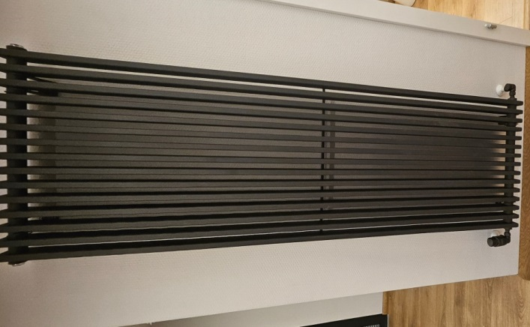
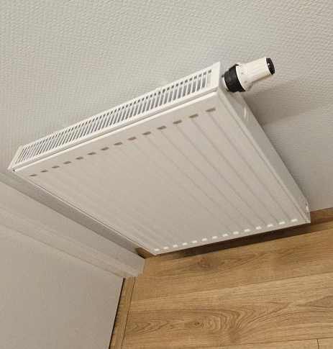
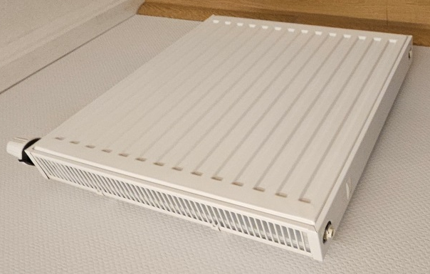
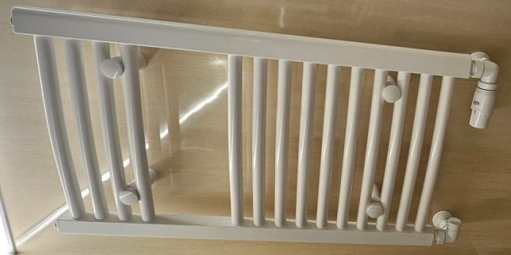

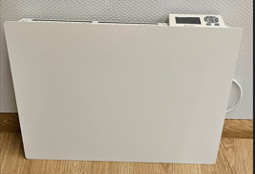
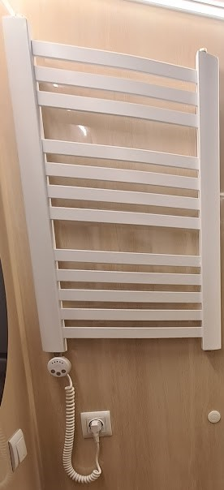
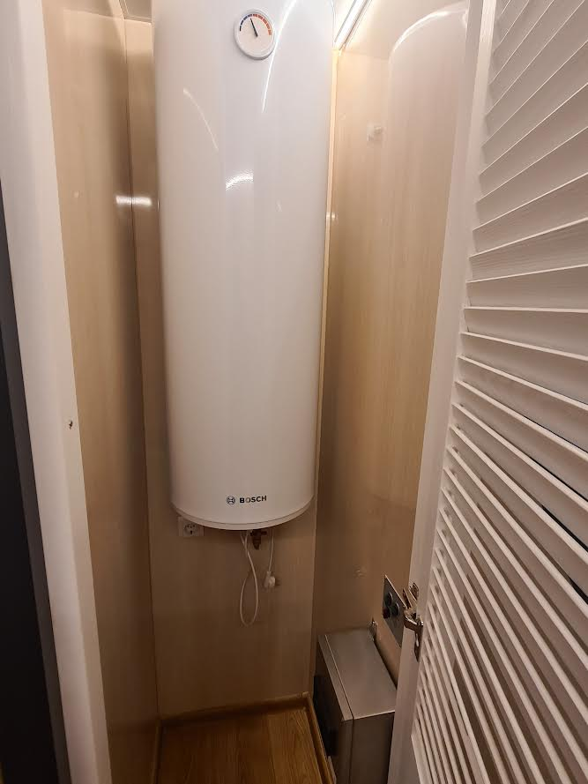
- Electric heating: Electric heating through radiators located in the salon, bathroom, and both bedrooms. Additionally, a boiler has been installed for heating water.

10. Preparing the engines for use

Before any risk occurs, the engines and the fuel system must be checked. Otherwise, there is a chance that the engines will not receive a sufficient amount of fuel or lubricating oil.

11. Fuel system
Before the engines can be started, it is necessary to check whether there is a sufficient amount of gasoline in the tanks. The gasoline tanks are located at the stern of the boat. The tanks must be taken out of the cabinet and filled with gasoline at the dock (without mixing with oil!).
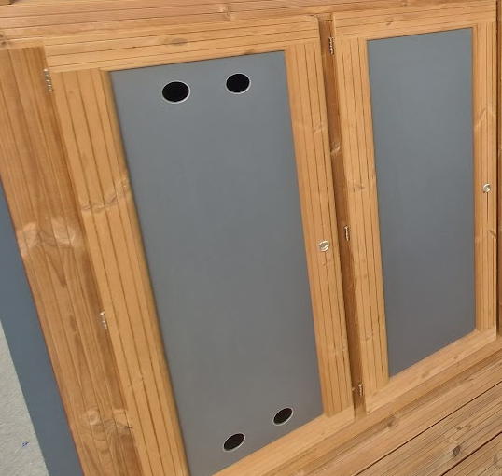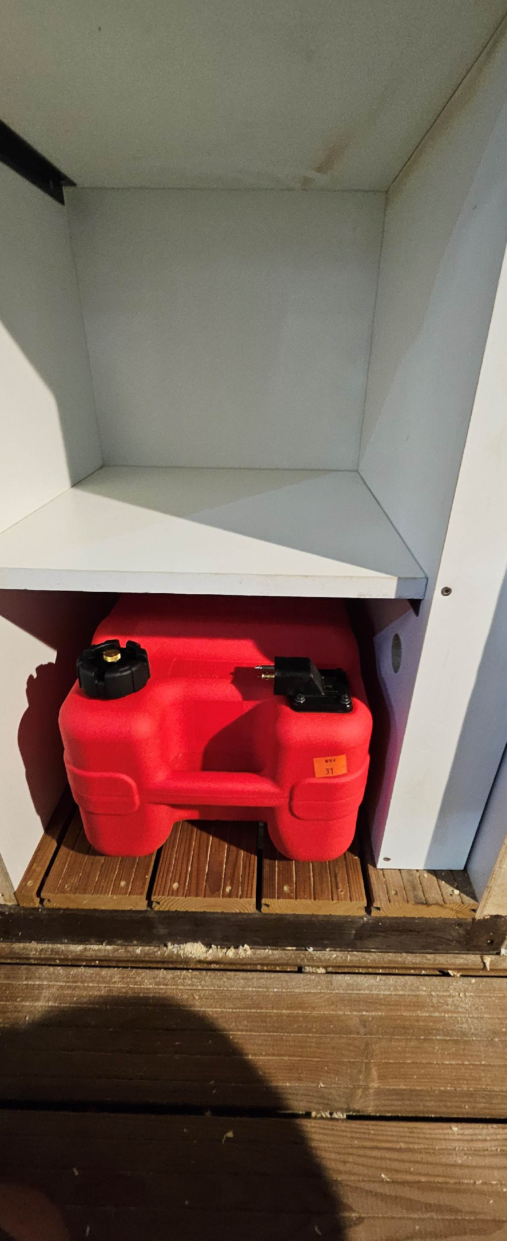
After filling the tanks, they must be placed back into the cabinet and the hoses reconnected. The Yamaha engines are designed to run on E10 gasoline.
Fire hazard! Explosion hazard! Gasoline vapors are explosive, so never spill gasoline inside the cabinet or on the boat. If a spill occurs, clean up any gasoline residue and ventilate the cabinet thoroughly before starting the engines.
Attention! The vent screw located on the filler cap must be open before starting the engines. Otherwise, the engines will shut down after a few minutes!
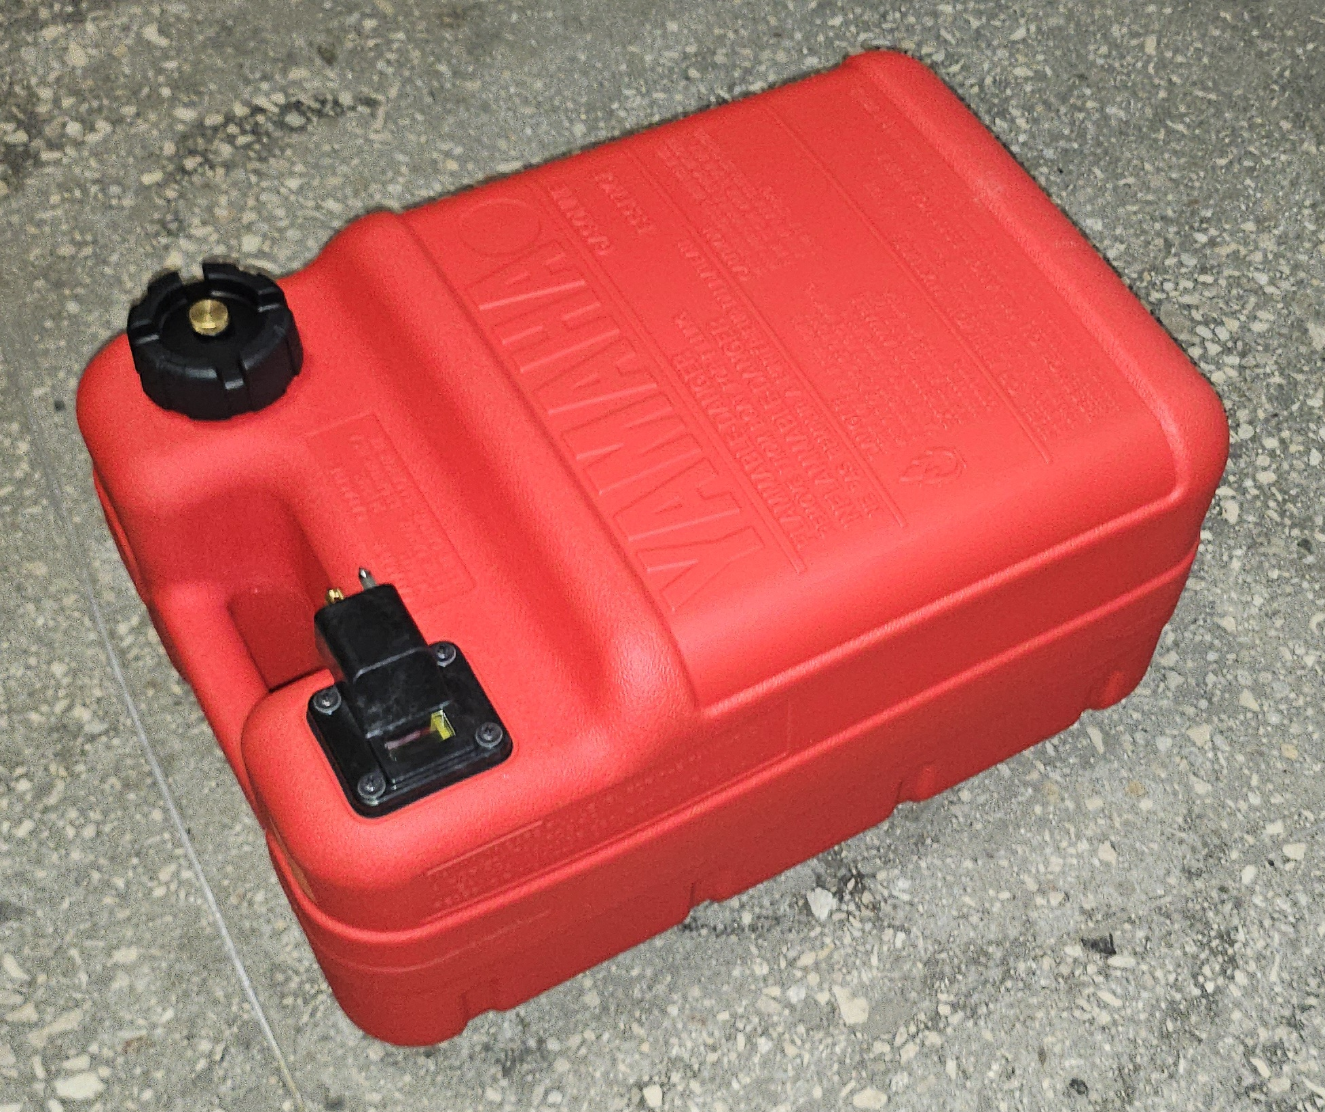
After refilling/checking the gasoline tanks, the fuel lines need to be filled using the manual pump. Both engines have a pump mounted on the steel frame. These pumps should be squeezed repeatedly until they become firm.

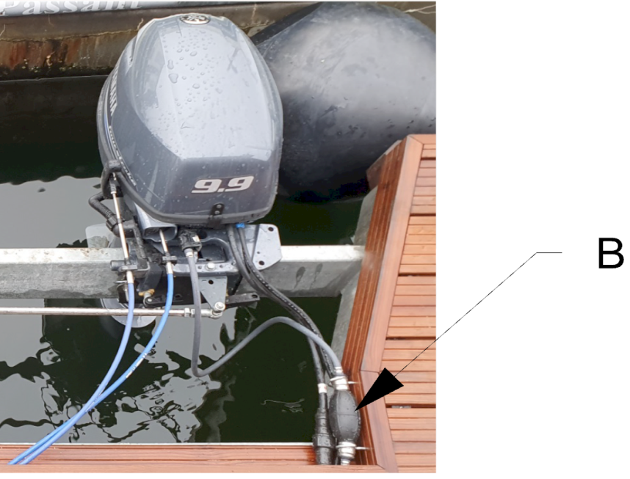

11.1 Lubricating oil level
Before starting the engines, check if there is a sufficient amount of oil in them. This is done by removing the cover and checking the oil level. The oil level indicator [A] is located on the starboard side of the engine.

The oil level should be between the minimum and maximum marks.
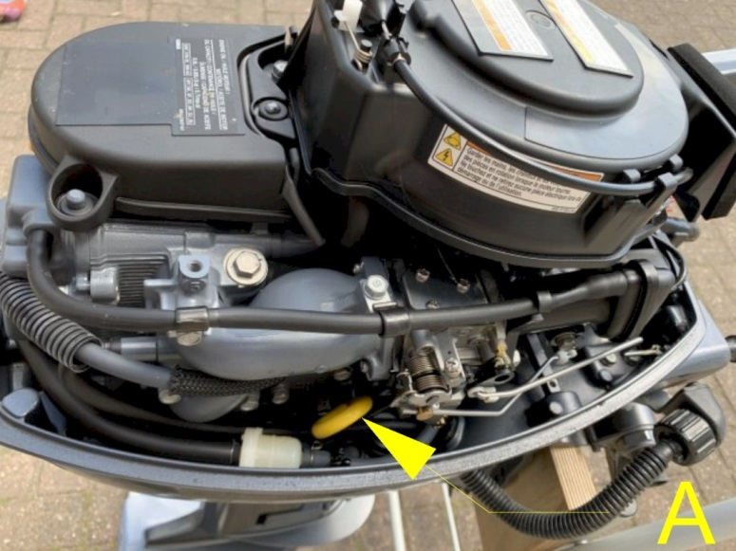

11.2 Engine start

The engines are controlled using the "throttle levers" located on the left and right sides of the helm console on the port and starboard sides. The left throttle lever controls the port engine, and the right throttle lever controls the starboard engine.
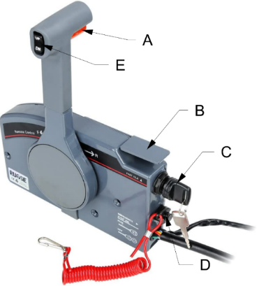
To start the engines, turn the key [C] with the throttle closed. To make starting easier, the metal levers [B] (idle speed) should be pulled out. Once the engines are running, the levers [B] should be pushed back in.To stop the engines, press the red button [D] or turn back the key [C].

Operation:
By pressing the red button [A] and pushing the lever forward, the engine moves forward. Pushing the lever further forward increases the engine speed (more thrust).
By pressing the red button [A] and pulling the lever backward, the engine shifts into reverse gear. Pulling the lever further backward increases the engine speed (more thrust in reverse).
When the lever is placed in the middle position, the gearbox is disengaged, and the propeller stops turning.
!DANGER TO LIFE! Before starting the engines or changing gears to forward/reverse, the helmsman must ensure that there are no swimmers around the Campi280.

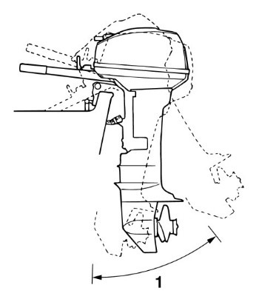 Pulling out the engines [applies only to 9.9 HP engines]:

This is done by sliding the black lever on the engine at the mounting point to the frame. To lift the engine, you also need to remove the safety pin that prevents the engine from moving forward or backward on its own.
After removing the safety pin, manually lift the engine to the desired position and secure it with the safety pin again.

12. Maneuvering

Maneuvering the Campi280, like any vessel, requires good steering skills. The Campi280 has a large air resistance and few means to limit drifting. The twin engines provide good maneuverability but can make handling more difficult for an inexperienced skipper.
Warning! If you don’t enjoy sailing with two engines and/or handling a wind-sensitive vessel, it is recommended to take sailing lessons.
Every boat reacts differently, so it is recommended to practice beforehand. When sailing for the first time, it is advisable, for example, to reverse several times to dock at a (lowered) pier just after leaving the departure port. This way, you’ll get to know how the boat behaves, which will make docking easier when arriving at the next port.

12.2 Mooring
When docking, possible forces acting on the mooring posts must be taken into account. The Campi must be prevented from docking directly to the shore. The drawing shows an example of the optimal angle for positioning the mooring lines relative to the posts.
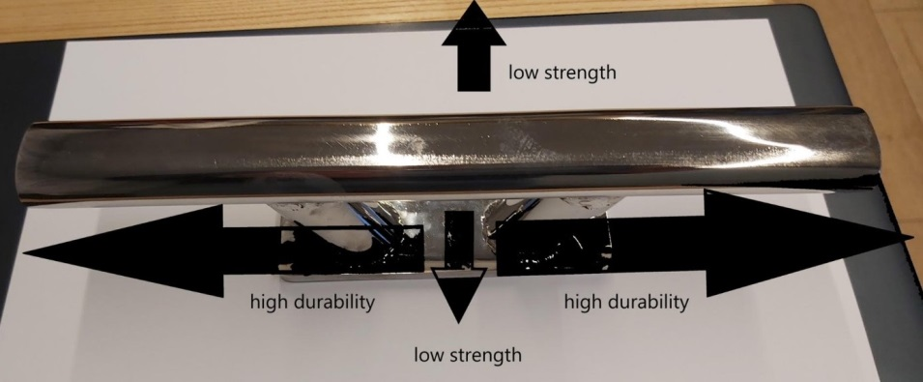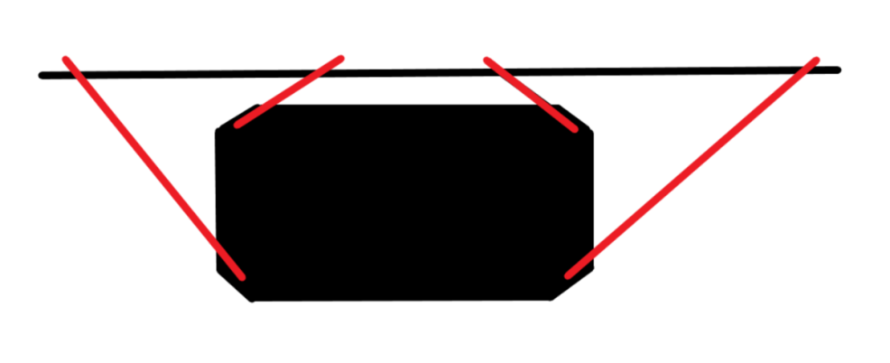
13. Overwintering
During freezing conditions, the Campi280 must be prepared for winter to avoid damage to various onboard systems. The Campi is equipped with different systems designed to prevent frost damage, which should be connected and checked before the onset of winter.
13.1 Mróz
If you use the boat during freezing periods, winter preparations are less complicated than when the boat is left unused for a long time. While staying on board, it is sufficient to connect the (optional) heating elements for the tanks and use the heating during your stay.
14.1.1 Heating cables (optional)
Turning on the heating cables.
14.1.2 Underfloor heating (optional)
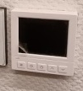
The heating mat installed on the boat is manually controlled with a +/- switch or optionally controlled via WiFi (requires WiFi on board {optional}).

13.2 Absence during frost or extended period

If no one stays on Campi for an extended period, the following steps must be taken:

Drain the water tank.

Drain the sewage tank.

Set the heating to winter mode.

If the central heating is not set to winter mode, it must be drained and the pipes blown out with air. The radiators are filled with antifreeze fluid.

13.3 Winterization of engines
In freezing conditions, the engines should be lifted. If they remain in the water, there is a risk of the engine's cooling system freezing.


14. Safety

Campi280 is equipped with various safety features to make sailing and staying on board as safe as possible. This chapter will explain these features and provide a list of recommendations for the owner regarding necessary purchases.

14.1 Man overboard prevention

To prevent anyone from falling overboard, the Campi280 is equipped with a railing. This fence helps prevent people from easily falling overboard. During the trip, you should not go beyond this railing.

In the event that someone falls overboard:

- Activate the alarm.

- Point out the person who fell overboard.

- Carefully maneuver the boat upwind toward that person.

- Turn off the engines.

- Throw a lifebuoy.
- Guide the person to the ladder at the stern.

Life is in danger! Never bring anyone close to running engines. Always turn off the engines in every situation.

15. Escape routes
Evacuation passages are depicted in Figure 34.
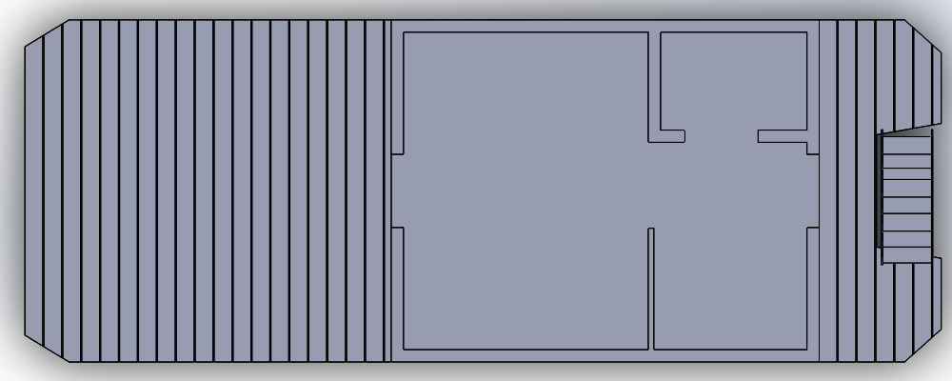

16. Advice on resources to acquire
The safety of the vessel and crew is the responsibility of the skipper. To sail safely, it is recommended to equip the Campi with the following safety equipment:
Fire and Safety Equipment
- A sufficient number of fire extinguishers
- Fire blankets
- Smoke detectors
- First aid kit
- Life jackets
- Lifebuoy
- Boathook
Navigation Equipment
- A sufficiently heavy anchor with a long rope (minimum 15 kg and at least 25 meters of rope)
- Several fenders of appropriate size
- A sufficient number of mooring lines — at least 4, each at least 1.5 times the length of the Campi

17. Error table
Problem | Possible Cause | Solution
No water pressure | Empty tank | Fill the tank
 | Water pump turned off | Turn on the pump in the distribution box
No electricity | Batteries empty | Check battery level on the inverter
Blown fuse | Check if any fuse is switched off
Residual current device (RCD) tripped | Check the RCD on the boat and on shore power
Engine won’t start | Empty fuel tank | Fill the fuel tank
Vent closed | Open the vent valve on the tank
Fuel not pumping | Squeeze the primer bulb until it hardens
No gas (in the cylinder) | Empty gas cylinder | Replace the gas cylinder
Valve closed | Open the valve in the gas box and under the stove
 | Water pump turned off | Turn on the pump in the distribution box

