Campi 400
User manual
PL-RIV000
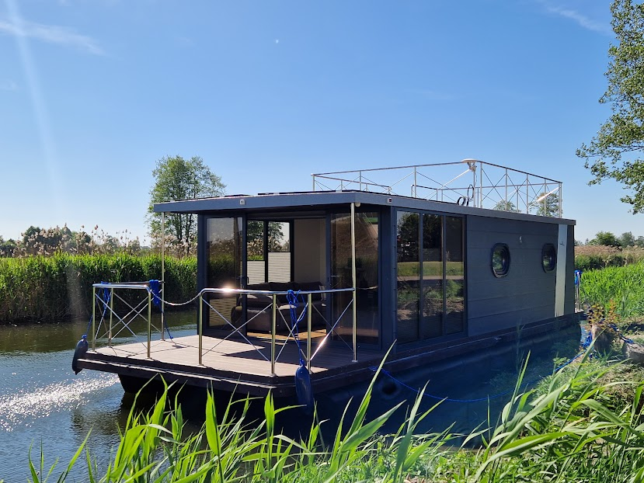

Version 1.1
Typ CV-, Gaz- i 9,9-KM MOTOR
Data 15.05.2021-02-02-2022
Autor M.J. van der Werf adaptierte TB
Spis treści
- General.................................................................................................................................................3 1.1. Introduction…..................................................................................................................3 1.2. Conditions at sea.............................................................................................................3 1.3. Warning symbols…..........................................................................................................4
- Ship details………...................................................................................................................................5 2.1. Basic dimensions……….....................................................................................................5 2.2. Deck systems………...........................................................................................................5 2.3. Tank capacity…………........................................................................................................5 2.4. Project category…............................................................................................................6 2.5. General plan……...............................................................................................................7
- Ship installations, description, and location………...............................................................................7 3.1. Control console.........................................................................................................8 1 1. Engine control............................................................................................................9 2. Steering wheel....................................................................................................................9 3 3. Ship sound signal…......................................................................................................9 4. Terrace lighting.............................................................................................................9 5 5. Navigational lighting....................................................................................................9
- Drinking and dirty water level indicator............................................................................................10
- Salon lighting………..............................................................................................................................11
- Camera system...................................................................................................................................11
- Description of electrical installation ……………...................................................................................12 7.1. Battery location and maintenance……..........................................................................13 7.2. Inverter / charger …..………............................................................................................14 7.3. Fuses…………...................................................................................................................16 7.3.1. Classification...............................................................................................................17
- Drinking water system.......................................................................................................................17 8.1. Filling the drinking water tank ……….............................................................................19 8.1.1. Switching between the tank and the permanent water connection........................20 8.1.2. Sewage disposal system…………..................................................................................20 8.1.3. Switching between the tank offboard / storage tank…………………………………...........20 8.1.4. Emptying the storage tank …………………………………………………...................................21
- Gas installation...................................................................................................................................21 9.1. Cylinder type / connections ……………...........................................................................22 9.2. Gas cylinder replacement.............................................................................................22
- Heating…............................................................................................................................................23 10.1. Operating modes .......................................................................................................24
- Sailing with Campi400 ..…..................................................................................................................24
- Fuel system………................................................................................................................................25 12.1 Lubricating oil level………..............................................................................................27 12.2. Engine start……………….................................................................................................27

- Maneuvering .....................................................................................................................................29 13.1. Double engines …….…..................................................................................................29 13.2.Mooring.......................................................................................................................30
- Overwintering …................................................................................................................................31 14.1. Frost............................................................................................................................31 14.2. Absence during frost or extended period…………………………......................................31 14.3. Winterization of engines………………...........................................................................31
- Safety................................................................................................................................................32 15.1. Man overboard prevention……………..........................................................................32
- Escape routes……..............................................................................................................................33
- Advice on resources to acquire……………………………..........................................................................33
- Error table……....................................................................................................................................34

1. General
1.1. Introduction
This manual is intended to serve as a technical manual with explanations, to explain the various systems on board the Campi400 and to identify possible faults.
of the various systems on board the Campi400 and to identify possible faults.
to identify possible faults.
1.2. Conditions at sea
Shut-off valve | Tap/valve to open or close the pipe
Port side | Left side of the vessel as seen from the front
Starboard | Right side of the vessel as seen from the front
The side it blows into | to which the wind blows
The side from which the wind blows | from which the wind blows
bolt | screw provides thrust in water
RPM | Rotations per minute
sewage | Sewage from the toilet (and sink)
The significant wave height | The significant wave height is the average height of the highest 1/3 of the measured waves
Balustrades | Handrails / guardrails preventing falling overboard
trimming | Adjusting the outboard motor longitudinally.
Ship horn | Sound signal horn
power supply | Electrical connection to shore (230V 50Hz).
hatch | The opening in the tank allowing inspection
Pressure regulator | Pressure reducing valve in the bottle to 50 mbar
pump | Black hand pump for pumping gasoline into the engines
Man overboard | Man overboard
Engine choke | Choke valve for the engine to suck in more gasoline

1.3 Warning symbols
The following symbols are used in this manual to identify dangerous situations and indicate hazards
WARNING FIRE HAZARD  
DANGER DANGER OF POLLUTION 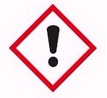 
LIFE THREAT


2. Ship details
2.1 Basic dimensions
Length: 12.50 [m]
Width: 4.00 [m]
Draft: 0.55 [m]
Height: 3.55 / 3.05 [m] with / without railing
Displacement: 8.5 [m3]
Year of construction: 2024
Shipyard: Rivo Sp. Z oo z. o. o.
2.2 Deck Systems

Engines: 2x Yamaha 9.9 HP
Solar panels: 6 x 6 V 225 [B]
Battery capacity: 48V 225 Ah
Inverter: 5 kW

2.3 Tank Capacities

Drinking water: 400 Liters
Sewage tank: 400 Liters
Gasoline: 2x 40 Liters

2.4 Project category

The interpretative category determines the maximum (meteorological) conditions (wind and sea conditions) for which the ship is designed. Campi400 has been designed and built for use in Interpretative Category D, with a recommended maximum capacity of 10 people. This category is based on ships designed for use in waves with a maximum height of 0.3 meters and wind force four. Category D "Inland Waters": Designed for navigation in protected waters along the coast, in small bays, on small lakes, rivers, and canals, with a maximum wind force of 4 and a maximum wave height not exceeding 0.3 meters, which is occasional. The minimum distance from passing ships should not exceed 0.5 meters

2.5 Identification number

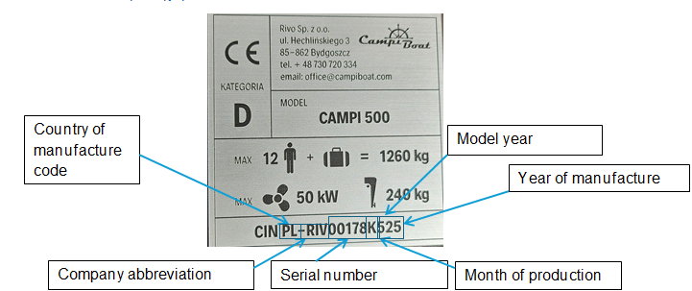

The identification number is divided into 6 parts, each of which is unique to each boat. To read the number, it should be read as follows: PL – Poland, Riv – RIVO, 00178 – the boat was the 178th to leave production, K – indicates the month; months are designated from A to L, in this case November, 5 – year of manufacture 2025, 25 – year of model approval 2025.
The identification number is the number on the basis of which the company can find precise information about the components used in a given boat; it is essential that this number is always provided in the event of a fault or breakdown on the boat. Should such a situation arise, please send a report to serwis.campiboat@gmail.com, including the boat’s identification number, a description of the fault, and photographs of the damage or the component that has failed.

2.5 General plan
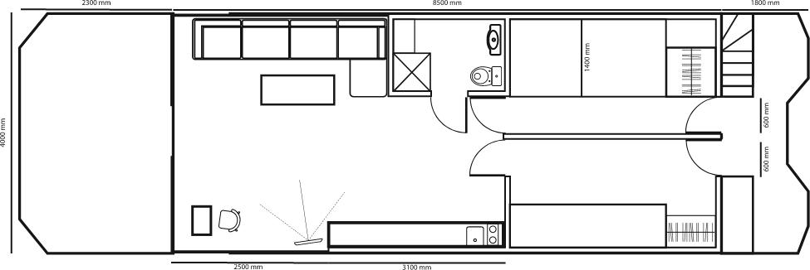

3. Ship installations, description, and location

In the following sections, technical operations and locations of onboard equipment are described. A detailed guide on starting up and sailing the Campi400 can be found in Chapter 4

3.1 Control console

The control console contains all the necessary switches and instruments for operating the engines and (navigation) devices of the Campi400. The image below shows the purpose of each button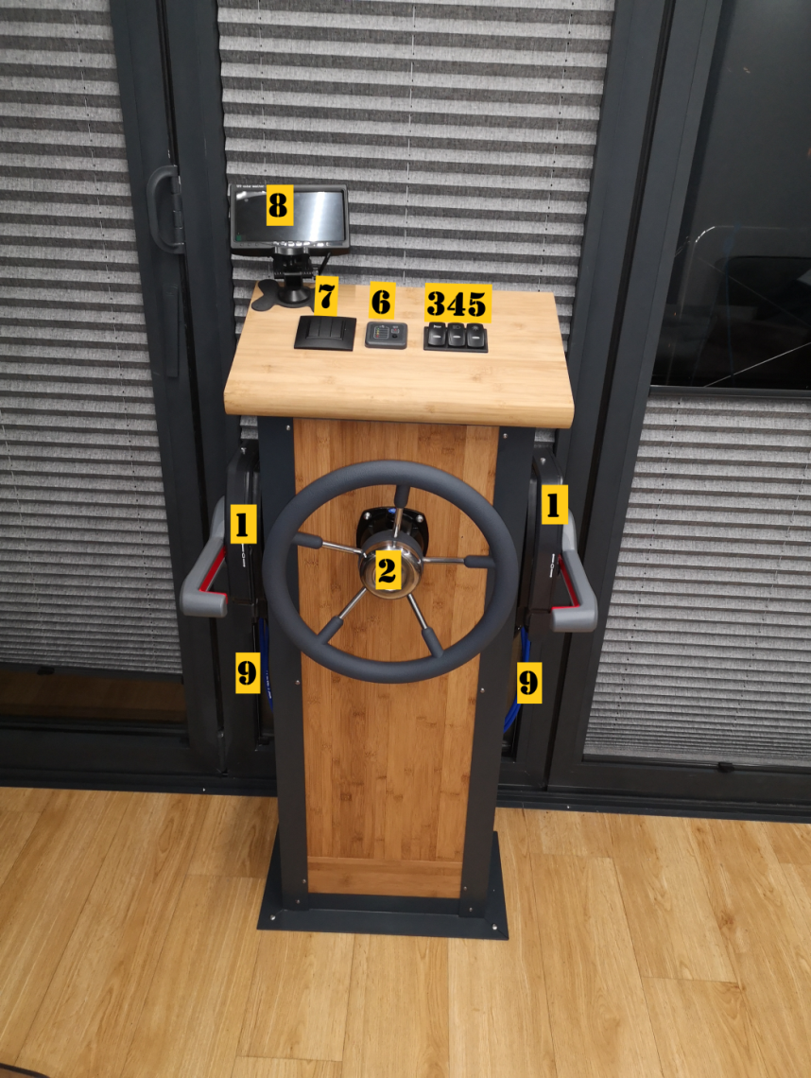

1.)Engine control, port and starboard 2.) Steering wheel 3.) Ship horn 4.) Terrace lighting
5.)Navigation lights 6.) Indicators for drinking water and sewage levels 7.) Salon lighting
8.) Camera systems

1 Engine control
Port and starboard engines: The engines are operated using "throttle levers" on the left and right sides of the control console. The throttle lever on the left side (port) controls the port-side engine, while the throttle lever on the right side (starboard) controls the starboard-side engine. Detailed instructions for operating the throttle levers and engines can be found in Chapter 4.
2 Steering wheel
The steering wheel is connected to both engines via a hydraulic system. By turning the steering wheel to the left, both engines rotate with the help of a hydraulic actuator, allowing the Campi400 to turn left or right depending on the forward position of the engines.
3 Ship sound signal
Pressing button 3 on the control console emits short sound signals from the ship's horn (horn).
4 Terrace lighting
Switching switch number 4 turns on or off the terrace lighting.
5 Navigational lighting
Switching switch number 5 turns on the navigation lights. The navigation lights consist of the following lamps:
I. Red light on the port side (port)
II. Green light on the starboard side (steuerbord)
III. Stern light (white lamp on the stern)
IV. Bow light (white lamp facing forward)
Navigation lights should be turned on during night voyages and in poor visibility conditions.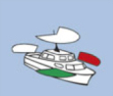

4 Drinking and dirty water level indicator

The following instrument measures the capacity of the drinking water and sewage tanks by pressing the black button. The drinking water tank is divided into 4 different lights.
• 4 points = 400 liters
• 3 points = 300 liters
• 2 points = 200 liters
• 1 point = 100 liters
When the light in figure 5 illuminates, it means that the sewage tank is full.
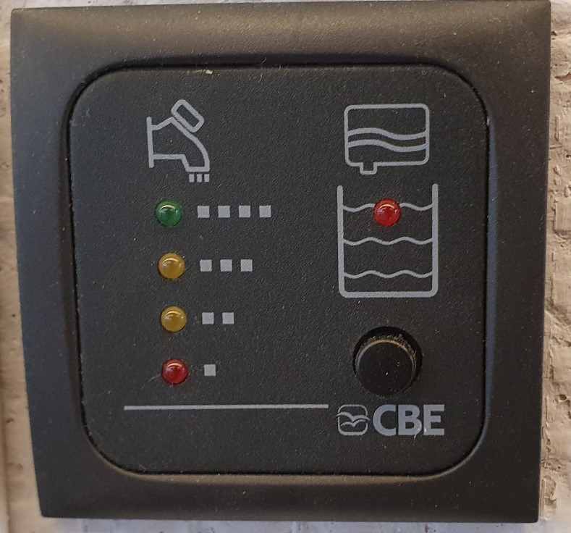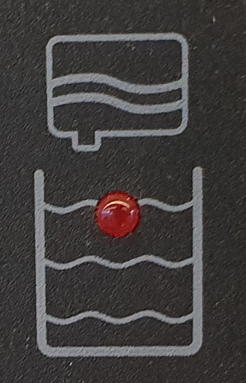

5. Salon lighting

These three switches control the LED lights in the salon of the Campi400.

6. Camera system
Figure 7 depicts the camera system. This system is turned on and off using the On/Off button on the screen. In Campi 400 and on the long gangway, there is only one camera at the back instead of two.
A. Port side stern
B. Starboard side stern
C. Reverse
D. Engine view
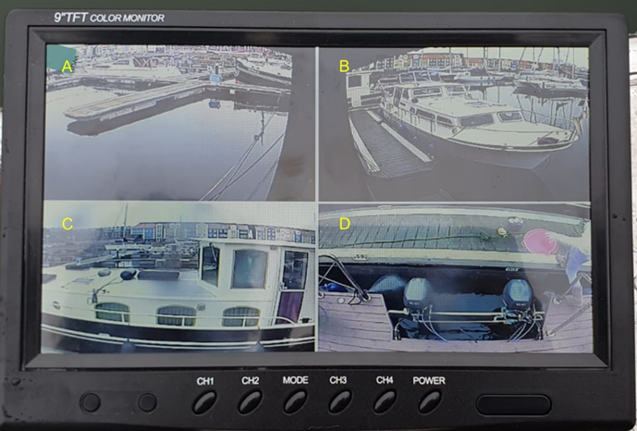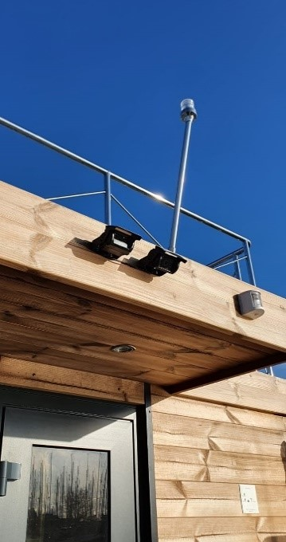

7. Description of electrical installation

The electrical installation of the Campi400 has been designed so that the ship can be powered by batteries independently of shore power. This is achieved through batteries, an inverter, and shore power/solar panels. Below is a brief description of these four components:
Batteries: The batteries (lead-acid accumulators) are charged using solar panels and/or shore power. Campi400 is equipped with 8 x 6V 220Ah batteries connected in series. These batteries have a total capacity of approximately 10.5 kWh at 48 volts. These batteries power the inverter with direct current and through DC/DC converters (48/24 & 48/12) supply small DC consumers, such as the ship's horn and navigation lights.
Inverter: The inverter converts 48-volt direct current to 230-volt alternating current (typically from a power socket). This alternating current is distributed throughout the ship and available from electrical outlets.
Solar panels: Solar panels generate energy to charge the batteries when Campi400 is not connected to shore power. On a sunny (summer) day, solar panels produce enough energy to fully power Campi400 and charge the batteries to full capacity. As dusk falls, the efficiency of solar panels decreases, and the batteries slowly discharge.
Shore power: When Campi400 is connected to shore power, it takes over the function of the inverter and battery charging along with the solar panels.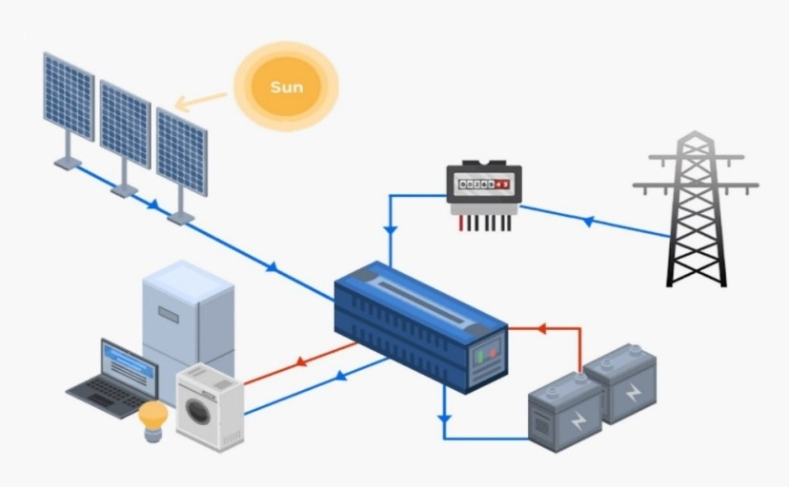

7.1 Battery location and maintenance
The batteries are located on the aft deck in the Campi400 cabinet or under the floor in the salon.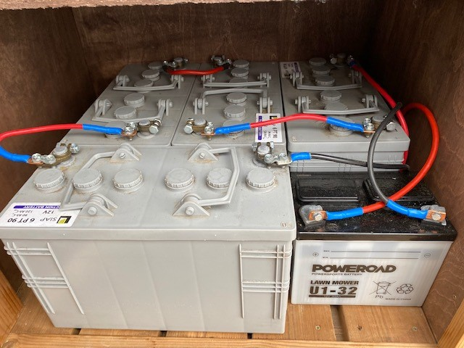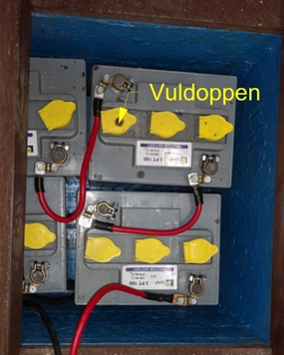
The filling caps.
Batteries sometimes need to be topped up with demineralized water (battery water) because this water evaporates during use. To avoid malfunction, the battery should be replenished when the water level drops to the minimum.
CAUTION! Acid may spray when the caps are removed, always wear eye protection and gloves! If acid sprays, use a sodium bicarbonate solution to clean it up.
- Open the battery using the "Flip Cap."
- Carefully pour demineralized water into the battery until you reach the maximum mark (the plates should be just submerged).
- Then close the caps on the top of the battery again.
!CAUTION! Never refill the battery with tap water. It contains minerals, salts, and calcium that can be harmful to the battery. These components affect the battery's performance and may even render it unusable.

7.2 Inverter / charger

The inverter/charger is a device that converts the direct voltage from the batteries and solar panels into 230-volt alternating current. This device also charges the batteries as soon as shore power is available. The inverter is an independent device that switches between shore power, batteries, and solar panels. The inverter is located behind the upper doors on the stern.
Additional information can be found in Appendix A.
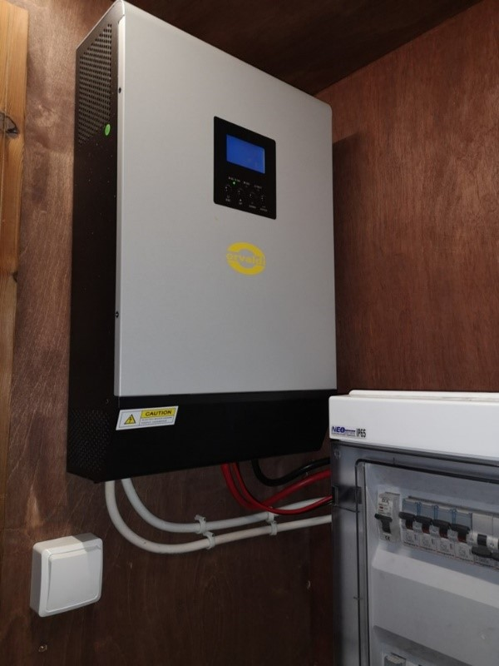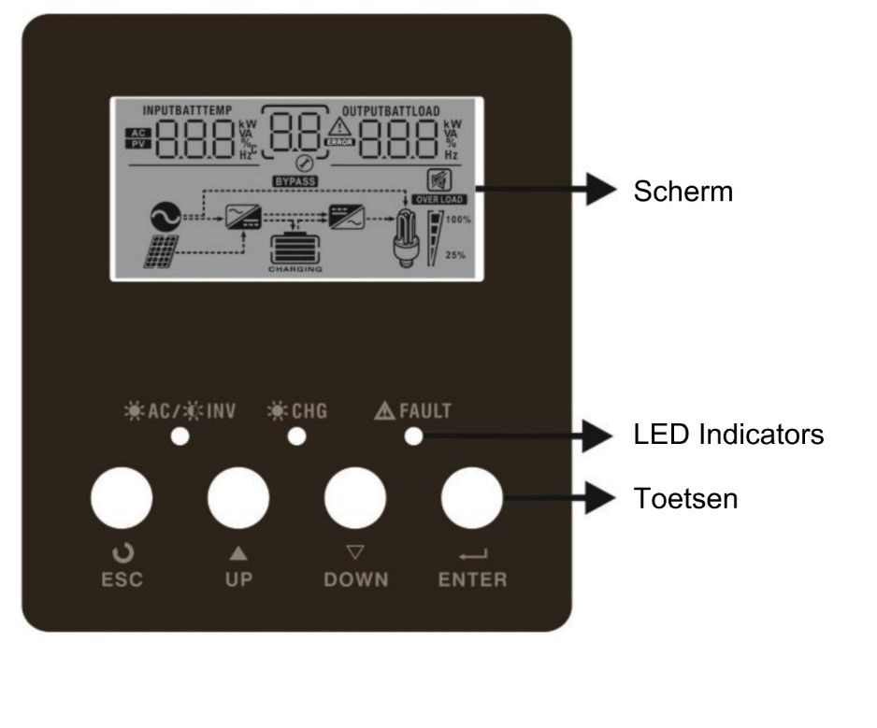
The LED indicator
switch
screen
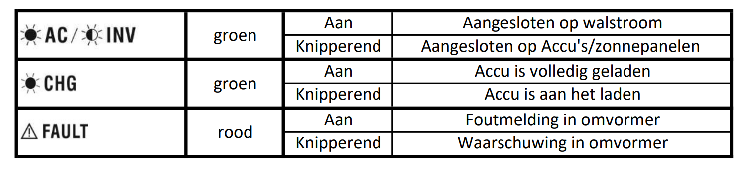
Table 1. The status of the inverter and Figure 10. Determine the inverter's status. On the screen, you can check whether the inverter is connected to shore power or if the power comes from the batteries (AC or INV), where alternating current means shore power is connected, and INV means the power comes from the batteries.
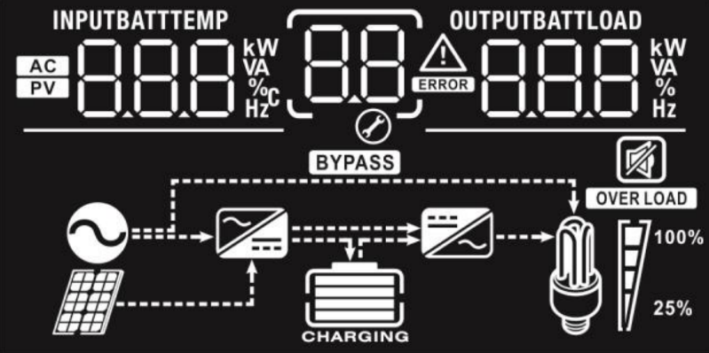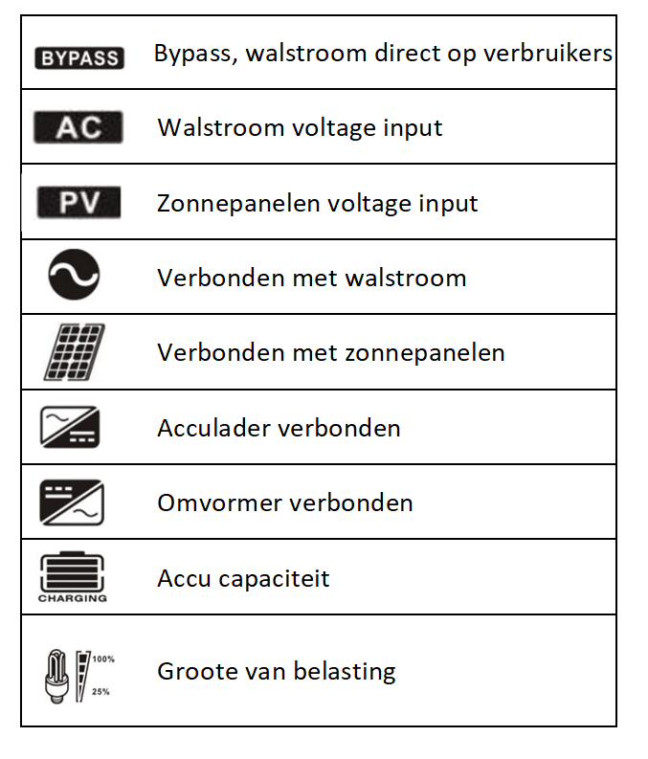
Situation 1. Connected to shore power: The following symbols are lit up:
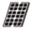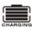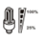
Situation 2. Not connected to shore power: The following symbols are lit up:

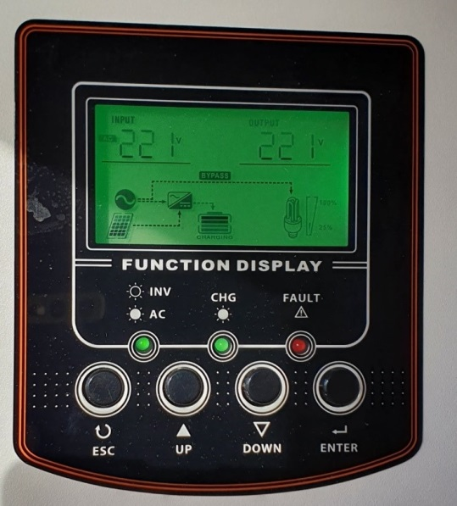

7.3 Fuses

The fuses are located behind the upper doors at the stern. Fuses distribute current throughout Campi400 and protect the installation from short circuits/overloads and earth faults. Below is a brief explanation of overload and earth fault:
Overload/Short Circuit: Overload occurs when the current flowing through the installation is greater than what the installation was originally designed for. Overload results in additional heat generation and can lead to machine shutdown.
Residual-current device (RCD): The residual-current device is an automatic switch that disconnects the electrical installation when a leakage current of a specified value occurs. This device prevents leakage current that could cause electric shock.
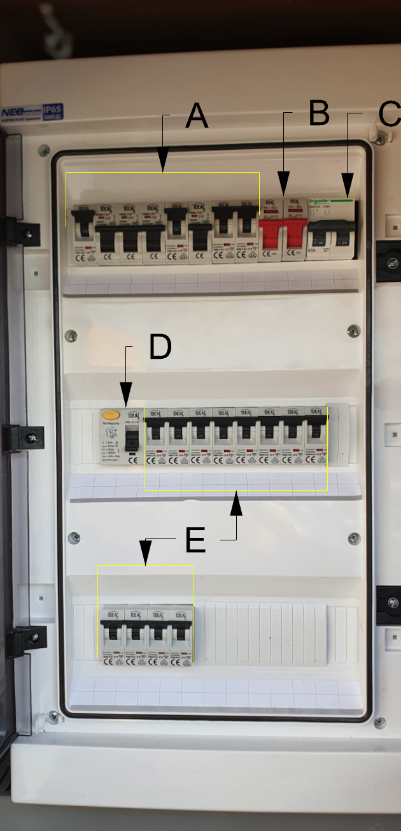

7.3.1 Classification
The distribution box is divided into two parts: the DC part A, B, and C, and the AC part D and E.
A. DC voltage switch
B. Battery
C. Solar panels
D. Residual-current device (RCD)
E. 230V AC machines
Next to the group field is a laminated A4 sheet with an overview, indicating the purpose of each device!
!LIFE THREATENING! Adjustments to electrical installations (and devices) may only be carried out by authorized personnel.
8. Drinking water system
Campi400 has a freshwater tank with a capacity of 400 liters. The tank is located beneath the floor between two float switches and is accessible through hatch [B]. The freshwater system consists of the following components:
A. Freshwater pump
B. Inspection hatch
C. Frost protection [optional]
D. Pump outlet pipe [optional]
E. Permanent water drain connection [optional]
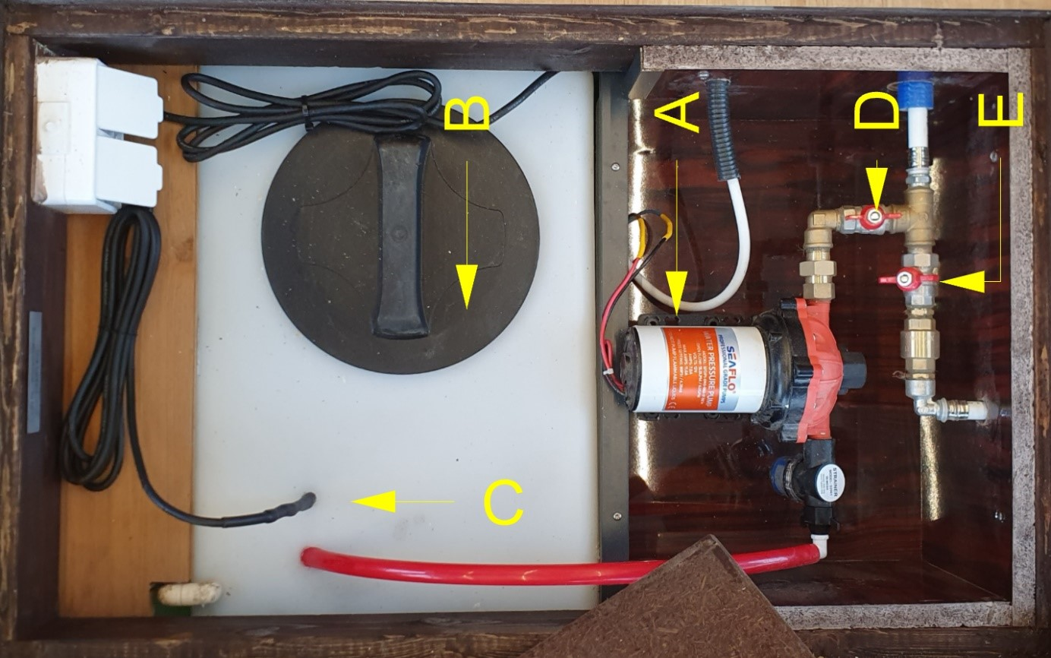
The freshwater pump activates when the pressure drops (when the faucet is open) and stops working when the pressure reaches the appropriate level. There is a possibility that the pump will continue to operate for a few minutes after the faucet is closed.
!WARNING! If the water tank is completely empty, the pump will still operate, trying to build up pressure. This will not work because the tank no longer contains water. In this case, the pump must be manually turned off by switching off switch X in the group field [see overview next to the group field]. After refilling the tank with water, the pump can be restarted.

Pompa wody pitnej (opcjonalne)
If Campi400 is equipped with the optional Marco pump, the pump automatically shuts off when there is no more water to pump. After refilling the tank with water, the pump must be manually reset. This can be done by pulling/putting back the plug in the group field (see overview). Bleeding the pump can also be facilitated by opening the Allen screw on the pump until water starts to leak out.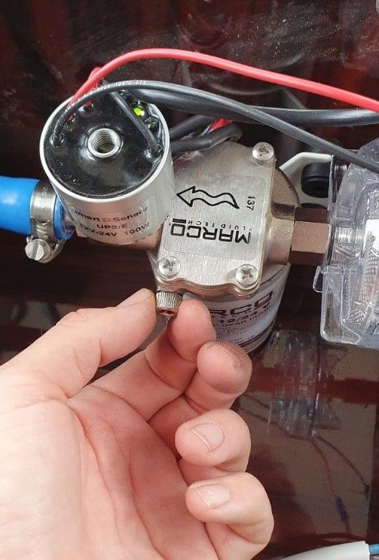
8.1 Filling the drinking water tank
The fresh water tank is filled through the drinking water filling hole in the central hatch at the stern in the port.
!CAUTION! Always flush the water hose for a few minutes before inserting it into the filling hole to prevent legionella.
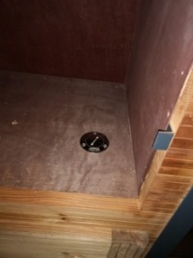

8.1.1 Switching between the tank and the permanent water connection

Optionally, Campi400 can be equipped with a permanent shore water connection. In this case, the pump must be turned off using switch X [see overview next to the group field], and valve D (in figure 14) must be perpendicular to the pipe, while valve E must be in the longitudinal direction of the pipe.

8.1.2 Sewage disposal system

Campi400 has a sewage tank with a capacity of 400 liters. The tank is located under the floor between two floats and is accessible through a hatch at the stern. Waste (from the shower, sink, and toilet) is collected in the sewage tank or can be directly discharged overboard.

8.1.3 Switching between the tank offboard / storage tank
Using the Y valves under hatch [C], you can switch between the tank / overboard discharge. There are two Y valves on board. Valve A - Black water (toilet), Valve B - Gray water (shower and sink), Valve C - Antifreeze [optional].
On Figure 16 below, the arrows indicate the direction of the sewage flow. In the example below, water enters the tank through Valve A along the arrows. By turning the blue knob, the flow direction changes, and water is discharged overboard. In the case of Valve B, water is discharged overboard along the arrows. By turning the black knob, the fluid flows into the tank.
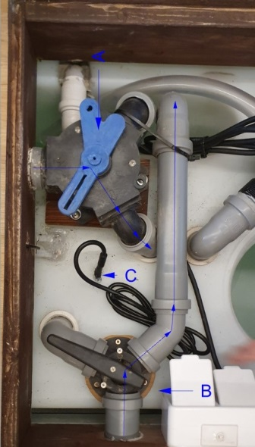
!WARNING! Discharging sewage into surface water is prohibited.

8.1.4 Emptying the storage tank
The sewage tank can be emptied by opening the shut-off valve shown in figure 18, which is located at the lowest point of the tank. After opening this valve, the contents of the tank flow into surface waters. The suction connection of the sewage tank is located at the rear of the port side of the ship at the level of the port float. The tank can be emptied in the port using this connection.
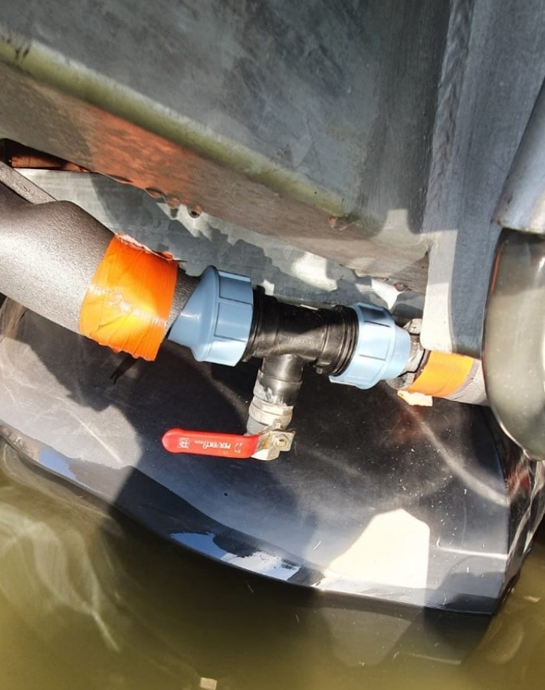

9. Gas installation

Propane-butane gas cylinders are located on the starboard side of the stern under the stairs. The gas system consists of the following parts:

A. Gas cylinder

B. Spare gas cylinder

C. Gas cylinder valve

D. Gas pressure regulator

E. Gas shut-off valve

The gas cylinder is filled with 10.5 kg of propane and is opened by opening the valve at the top of the cylinder. The gas flows through the pressure regulator, then through the gas shut-off valve, and through pipes to the Campi.

9.1 Cylinder type / connections
The type of gas used at the campsite should always be propane. This gas vaporizes even at lower temperatures, allowing the central heating to be powered even in winter. The gas pressure regulator is most likely equipped with a DIN connector and in such a case should be connected only to a DIN gas cylinder! There are two options for connecting the gas cylinder:
- Shell connection,
- DIN connection.
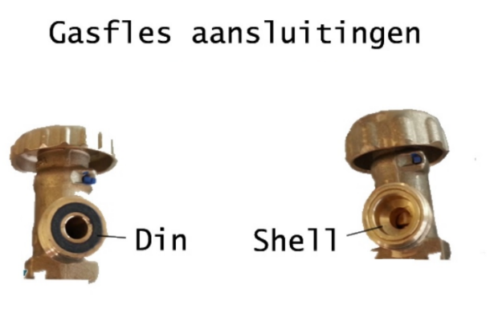
The DIN connector has a raised metal edge but does not have a rubber seal around the pin. The raised edge perfectly matches the rubber seal found on DIN fittings. The Shell-type connection or those with external threads have a sealing ring around the pin to seal the standard external threaded connection.
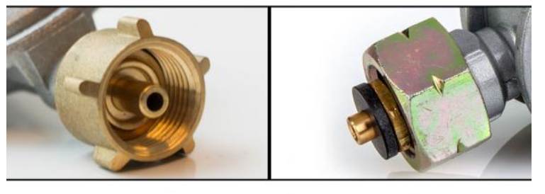
9.2 Gas cylinder replacement

As soon as a gas cylinder is empty, it should be replaced with a full one. Below is a step-by-step plan for safely replacing the cylinder and checking for leaks: Disconnect
1. close the gas supply shut-off valve E.
2. close valve C on the gas cylinder
3. unscrew the gas pressure regulator from the gas cylinder (this is a left-hand thread, so to unscrew it, turn it clockwise).

Connecting:
- Check if the gas pressure regulator and the gas cylinder are of the same type (DIN or Shell).
- Inspect the gas pressure regulator for any damages.
- Connect the gas pressure regulator to the cylinder, tighten it manually, and gently tap it with the gas cylinder wrench (or a spanner).
- Manually open the valve on the gas cylinder.
- Apply soap solution or use a gas leak detection spray on the connection.
- Are there any bubbles forming? If yes, immediately close valve C and check the connection.
- If there are no bubbles, you can open the gas tap valve E.
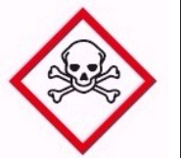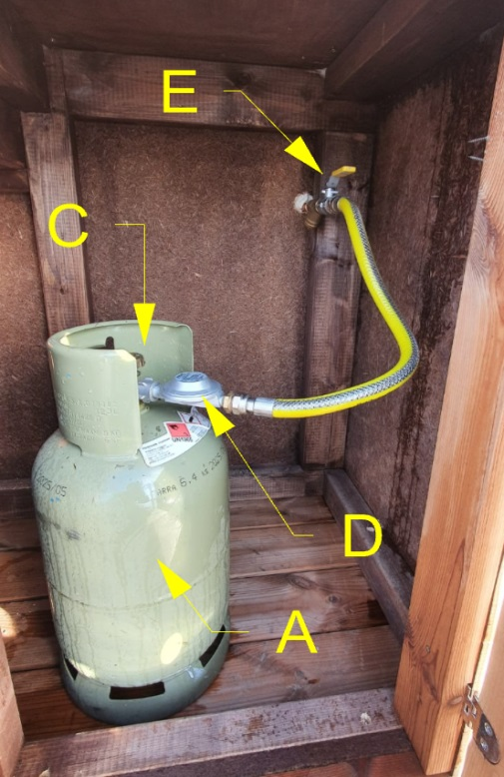
!Fire hazard, life-threatening! A leaky gas system can lead to life-threatening situations. Gas installations should be inspected by accredited gas installers at least every 3 years.

10. Heating
The central heating system is located in the cabinet next to the shower cabin. This boiler provides both heating and hot water. The boiler burns propane gas from the Campi400 cylinders. The temperature in each room can be controlled using thermostat valves on the radiators. The gas valve must be open to use the central heating (even if the central heating is frost-protected)! After changing the gas cylinder or when it is empty, connect a new cylinder as described earlier and leave the heater on for about 2 minutes to remove air from the system.
Note: At the end of the heating season, do not close all thermostat valves. This will cause the temperature at the inlet to be higher than the temperature at the outlet, resulting in an error message. It is preferred to set the temperature on the Thermet heating control panel.
For additional information about the Thermet, refer to Appendix B.
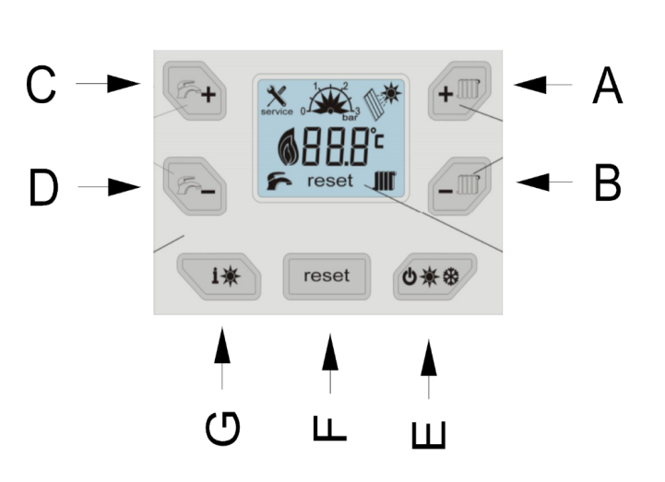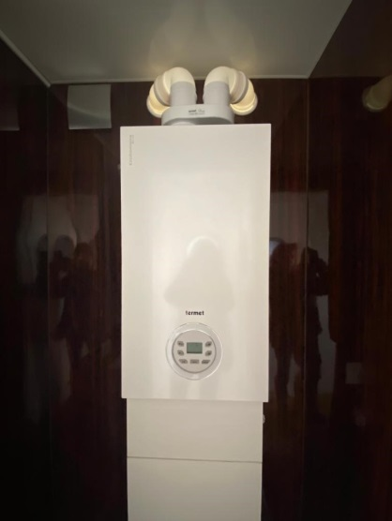
A. Heating temperature + B. Heating temperature - C. Hot water temperature + D. Hot water temperature - E. Operating mode (summer, winter, frost protection) F. Reset button G. Information mode
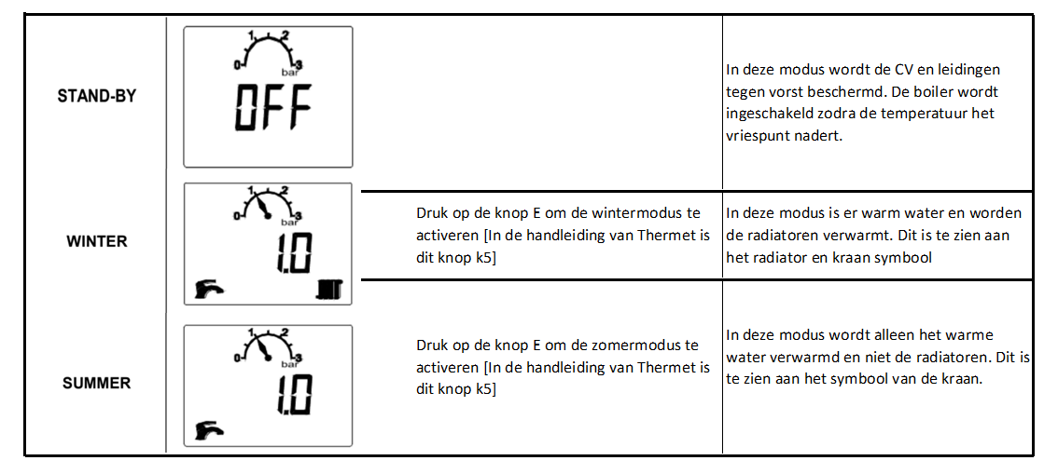
10.1 Operating modes

11. Sailing with Campi400

Before any potential hazard arises, it's crucial to check the engines and fuel circuit. Otherwise, there's a chance that there won't be enough fuel or lubricating oil for the engines. More information about the engines can be found in Appendix C.

12. Fuel system

Before the engines can be started, ensure that there is enough gasoline in the tanks. The gasoline tanks are located on the port stern. The tanks must be taken out of the locker and filled with gasoline onshore (without mixing with grease!).
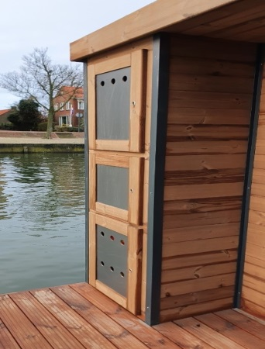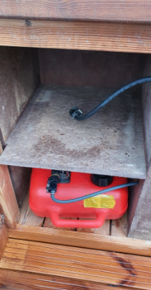
After filling the tanks, place them back in the locker and reconnect the hoses. Yamaha engines are suitable for use with E10 gasoline.
! Fire hazard! ! Explosion hazard! Gasoline vapors are explosive, so never spill gasoline in the locker or on the boat. If this happens, clean up any gasoline residue and ventilate the locker before starting the engines.
!Attention! The ventilation screw [A] must be open before starting the engines. Otherwise, the engines will shut down after a few minutes!
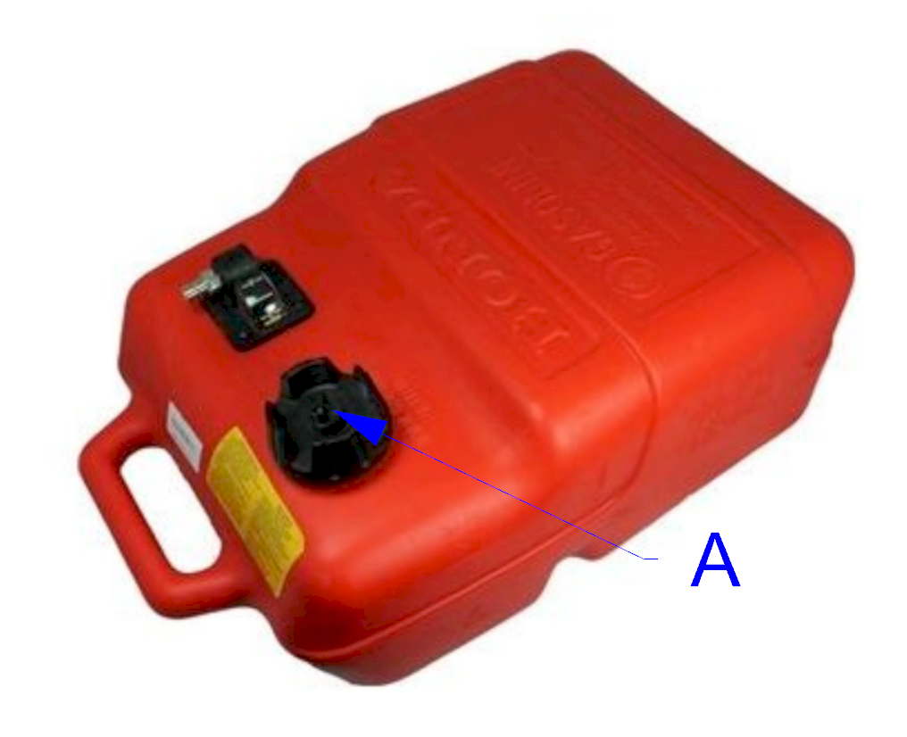

After refilling/checking the gasoline tanks, gasoline should be filled using the priming bulb [B]. Both engines have a bulb mounted on a steel frame. These bulbs should be squeezed until they become firm.

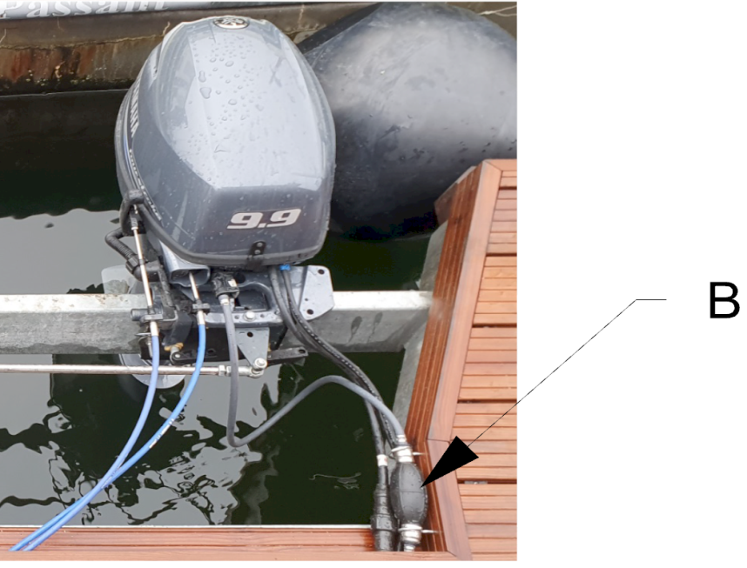

12.1 Lubricating oil level
Before starting the engines, it is necessary to check if there is a sufficient amount of oil in the engines. This is done by removing the cover and checking the oil level. The oil level indicator [A] is located on the starboard side of the engine.

The oil level should be between the minimum and maximum levels.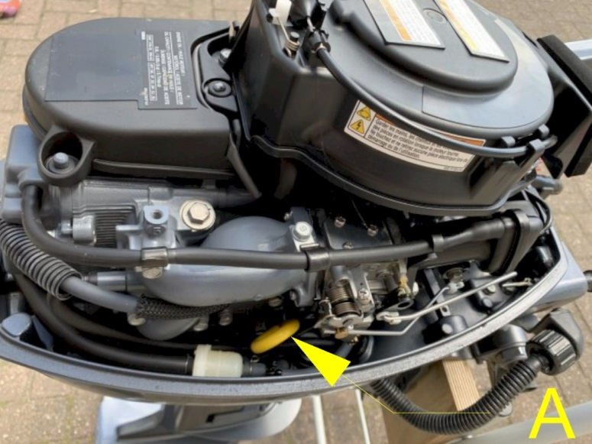

12.2 Engine start
The engines are controlled using "throttle levers" located on the port and starboard sides of the steering console. The left throttle lever controls the port engine, and the right throttle lever controls the starboard engine. To start the engines, turn the key [C] with the throttle closed. To facilitate starting, the metal levers [B] (idle speed) should be extended. Once the engines are running, push the levers [B] back in. Shutdown The engines can be shut down by pressing the red button [D] or by turning the key [C] backwards.

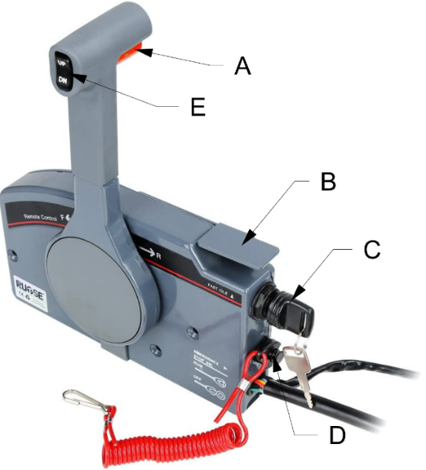
Operation
By pressing the red button [A] and pushing the lever forward, the engine is driven forward. Further pushing the lever forward increases the engine's rotational speed (more momentum).
By pressing the red button [A] and pulling the lever back, the engine is switched to reverse gear. Further pulling back the lever increases the engine's rotational speed (more momentum in reverse). When the lever is placed in the middle position, the gearbox is disengaged, and the propeller stops spinning.
!LIFE THREAT WARNING! Before starting the engines or shifting into forward/reverse, the helmsman
must ensure that there are no swimmers around the Campi400.

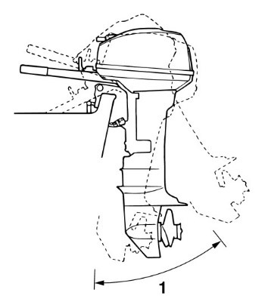 Engine Adjustment [applies only to 9.9 HP engines]
Engines can be adjusted by pressing the black button [E]. Engine adjustment allows for raising or lowering them in the water.

13. Maneuvering
Maneuvering the Campi400 requires good steering skills, as with any boat. The Campi400 has a large air resistance and few drift-limiting means. The twin engines provide good maneuverability but can make maneuvering more challenging for an inexperienced skipper.
!Caution! If you're not comfortable sailing with two engines and/or on a wind-sensitive vessel, consider taking boating lessons.
every boat reacts differently, previous practice is recommended. When sailing for the first time, it is advisable, for example, to moor back at the (lowered) pier a few times just after leaving the departure port. In this way you will learn how the boat behaves, which will make it easier to moor when you arrive at the next port.

13. Double engines
Campi400 is equipped with two engines. This means that control can be done by turning the steering wheel, but also by manipulating the engines. Figure 30 shows what happens when one of these engines is running.
Situation 1) Portside engine forward, starboard engine neutral: Result: The boat rotates to starboard. This effect can be significantly amplified when the starboard engine is also in reverse.
Situation 2) Starboard engine forward, portside engine neutral: Result: The boat turns to port. This effect can be significantly amplified when the portside engine is also in reverse.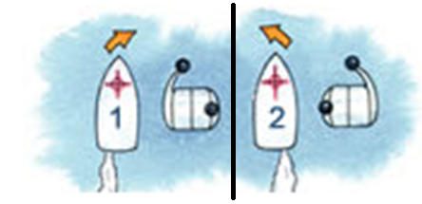
Thanks to the fact that both engines work in opposite directions and provide additional throttle if needed, Campi400 can rotate around its own axis without gaining momentum. Figure 31 shows how to position the throttles and the effect it has on rotation.
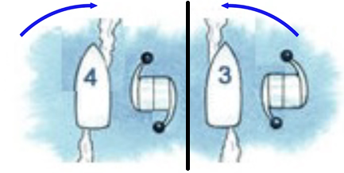

13.2 Mooring
When mooring, possible forces on the mooring poles must be taken into account. Campi must be restrained from mooring to the shore. Figure 32 shows an example of the optimum angle of the mooring lines in relation to the poles.
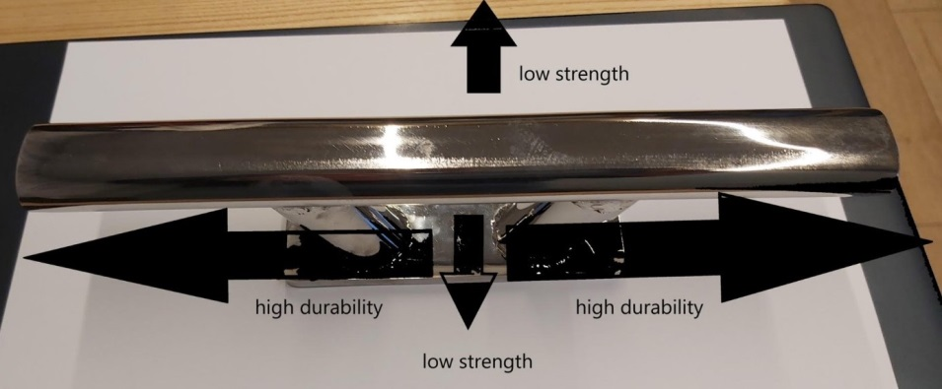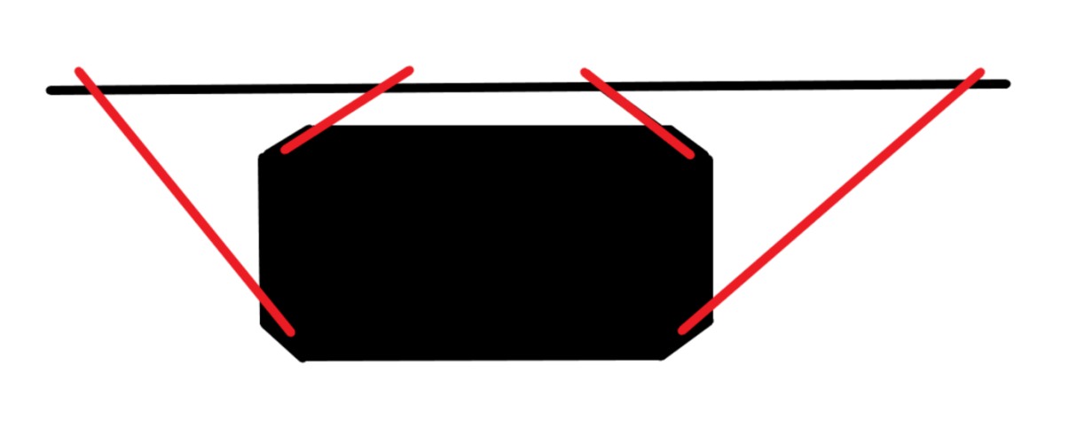
14. Overwintering

During freezing temperatures, Campi400 must be winterized to avoid damage to various onboard systems. Campi is equipped with various systems to prevent damage caused by freezing, which must be connected and checked before the onset of winter.

14.1 Frost

if you're staying at the campsite during freezing periods, winter preparations are less complicated than when nobody is there for an extended period. During your stay onboard, simply connect the (optional) heating elements of the tanks and use the heating during your stay.

14.2 Absence during frost or extended period

If nobody is staying in the Campi for an extended period of time, the following actions should be taken:

Empty the water tank.

Empty the accumulator tank.

Set the heating to winter mode, see 3.8.1 Heating operation mode.

If the central heating is not set to winter mode, it should be emptied, and the pipes should be blown with air. The radiators are filled with non-freezing fluid.

14.3 Winterization of engines
In freezing conditions, the engines should be raised using the pull cord handle. If the pull cord handle remains in the water, there is a risk of the engine cooling system freezing. Note! If the pipes are not properly prepared for winter or if the central heating fails (e.g., due to an empty gas cylinder), the pipes may be damaged.


15. Safety

The Campi400 is equipped with various safety features to ensure safe sailing and onboard stay. This chapter will explain these features and provide a list of recommendations for the owner's purchase.

15.1 Man overboard prevention

To prevent someone from falling overboard, the Campi400 is equipped with a railing. This railing prevents people from easily falling overboard. During the journey, you should not go beyond this railing.
In case someone falls overboard:
- Activate the alarm.
- Point out the person who fell overboard.
- Carefully sail upwind to reach that person.
- Turn off the engines.
- Guide the person to the ladder at the stern.
Life is in danger! Never lead anyone near the operating engines. In any case, turn off the engines.

16. Escape routes
Evacuation passages are depicted in Figure 34.
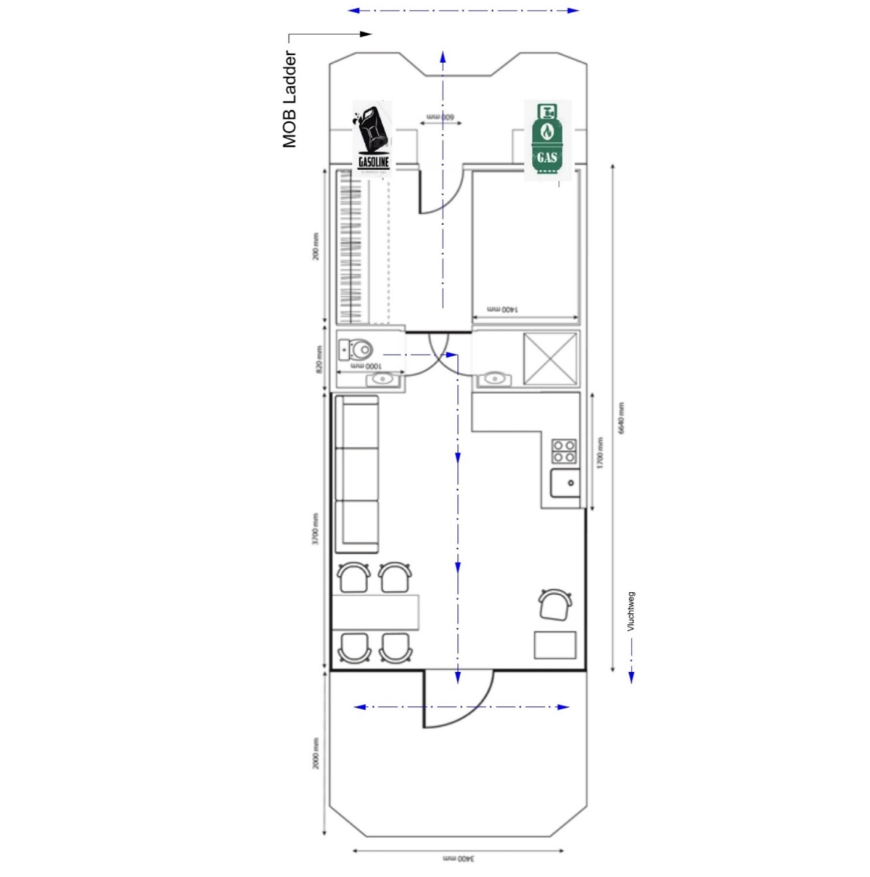

17. Advice on resources to acquire
The safety of the ship and crew lies in the hands of the skipper. To sail safely, it is recommended to equip the Campi with the following safety equipment:
Fire safety equipment:
- Sufficient number of fire extinguishers
- Fire blankets
- Smoke detectors
- First aid kit
Navigational equipment:
- Sufficiently heavy anchor with a long line (minimum 15 kg and at least 25 m of line)
- Multiple fenders of appropriate size
3. Sufficient number of mooring lines, at least 4 pieces with a length of at least 1.5 times the length of the Campi

18. Error table
problem | Possible cause | solution
No water pressure | Tank empty | Fill the tank
 | Water pump turned off | Turn on the pump in the switch box
No electricity | Empty batteries | Check the battery level in the inverter
 | fuse | Check if none the fuse in not off
 | Earth leakage circuit breaker | Check the breaker residual current on boat and on land
The engine does not start | Petrol tank empty | Fill the gasoline tank
 | Ventilation closed | Open the valve venting on tank
 | Gasoline does not pump | Squeeze the bellows untill
No gas (in cylinder) | Empty cylinder | Replace the gas cylinder
 | the valve is closed | Open the valve in the gas box and under the heater
Heating does not come on | Empty cylinder | Replace the gas cylinder

